Volere
Requirements Specification Template
Edition 20—2020

by James Robertson & Suzanne Robertson
principals of the Atlantic Systems Guild
The Volere Requirements Specification Template is intended for use as a basis for discovering and communicating your requirements. The template provides sections for each of the requirements types appropriate to today's software systems. You may download the template from the Volere site and adapt it to your requirements process and requirements tool. The template is process independent and can be used by Agile, Traditional, and Outsourced projects. The template can be used with any combination of automated tools you are using see http://www.volere.co.uk/tools.htm for a summary of available tools.
The template may not be sold, or used for commercial gain or purposes other than as a basis for a requirements specification without prior written permission. The Template may be modified or copied and used for your requirements work, provided you include the following copyright notice in any document that uses any part of this template:

1. The Purpose of the Project 12
1a. The User Business or Background of the Project Effort 12
1b. Goals of the Project 12
2. The Stakeholders 14
2a. The Client 14
2b. Other Stakeholders 14
2d. The Hands-On Users of the Product 16
2e. Personas 17
2f. Priorities Assigned to Users 17
2g. User Participation 18
2h. Maintenance Users and Service Technicians 18
3. Constraints 18
3a. Solution Constraints 19
3b. Implementation Environment of the Current System 20
3c. Partner or Collaborative Applications 20
3d. Off-the-Shelf Software 22
3e. Anticipated Workplace Environment 23
This section outlines the critical deadlines and time-based limitations that directly impact the scope and prioritization of requirements for the Breadfast CRM system. 24
Primary Schedule Constraints 24
3g. Budget Constraints 26
3h. Enterprise Constraints 28
4. Naming Conventions and Terminology 31
4a. Glossary of All Terms, Including Acronyms, Used by Stakeholders Involved in the Project 31
5. Relevant Facts and Assumptions 38
5a. Relevant Facts 38
5b. Business Rules 39
5c. Assumptions 39
6. The Scope of the Work 41
6a. The Current Situation 42
6b. The Context of the Work 42
6c. Work Partitioning 44
6d. Specifying a Business Use Case (BUC) 47
7. Business Data Model and Data Dictionary 49
7a. Business Data Model 49
7b. Data Dictionary 53
8. The Scope of the Product 62
8a. Product Boundary 62
8b. Product Use Case Table 65
9. Functional Requirements 69
9a. Functional Requirements 69
Non-functional Requirements 81
10. Look and Feel Requirements 82
10a. Appearance Requirements 82
10b. Style Requirements 82
11. Usability and Humanity Requirements 83
11a. Ease of Use Requirements 84
11b. Personalization and Internationalization Requirements 85
11c. Learning Requirements 86
11d. Understandability and Politeness Requirements 87
11e. Accessibility Requirements 88
11f. Convenience Requirements 88
12. Performance Requirements 89
12a. Speed and Latency Requirements 89
12b. Safety-Critical Requirements 90
12c. Precision or Accuracy Requirements 92
12d. Reliability and Availability Requirements 92
12e. Robustness or Fault-Tolerance Requirements 93
12f. Capacity Requirements 94
12g. Scalability or Extensibility Requirements 94
12h. Longevity Requirements 95
13. Operational and Environmental Requirements 95
13a. Expected Physical Environment 95
13b. Wider Environment Requirements 96
13c. Requirements for Interfacing with Adjacent Systems 97
13d. Productization Requirements 97
13e. Release Requirements 98
13f. Backwards Compatibility Requirements 99
14. Maintainability and Support Requirements 99
14a. Maintenance Requirements 99
14b. Supportability Requirements 100
14c. Adaptability Requirements 100
15. Security Requirements 101
15a. Access Requirements 101
15b. Integrity Requirements 102
15c. Privacy Requirements 103
15d. Audit Requirements 104
15e. Immunity Requirements 104
16. Cultural Requirements 105
16a. Cultural Market Requirements 105
16b. Cultural Diversity and Inclusion Requirements 106
17. Compliance Requirements 106
17b. Standards Compliance Requirements 107
Project Issues 107
18. Open Issues 108
19. Off-the-Shelf Solutions 109
19a. Ready-Made Products 109
19b. Reusable Components 110
19c. Products That Can Be Copied 110
20. New Problems 111
20a. Effects on the Current Environment 111
20b. Effects on the Installed Systems 111
20c. Potential User Problems 112
20d. Limitations in the Anticipated Implementation Environment That May Inhibit the New Product 112
20e. Follow-Up Problems 113
21. Tasks 113
21a. Project Planning 113
21b. Planning of the Development Phases 114
22. Migration to the New Product 115
22a. Requirements for Migration to the New Product 115
22b. Data That Has to Be Modified or Translated for the New Product 116
23. Risks 117
24. Costs 119
25. User Documentation and Training 120
25a. User Documentation Requirements 120
25b. Training Requirements 124
26. Waiting Room 128
27. Ideas for Solutions 134

1. The Purpose of the Project

1a. The User Business or Background of the Project Effort
Breadfast is a fast-growing food delivery company that currently suffers from fragmented customer and order data spread across multiple disconnected systems, as stated in the System Vision Document. This causes difficulties for customer support agents providing quick and consistent service, leads to miscommunication between departments due to lack of a shared real-time view of orders, and results in inefficient delivery operations because rider assignments are done manually with limited visibility.
Additionally, senior management struggles to make data-driven decisions due to the lack of integrated reports and analytics, while staff spend excessive time on repetitive manual tasks such as updating records across different systems.
The purpose of this project is to develop a unified CRM system that integrates customer information, order management, delivery and dispatch operations, inventory and supplier management, and sales & analytics into one centralized platform. The system will support operational staff (Customer Support Agents, Delivery Dispatchers, Inventory Managers, and Sales Team) in performing their daily tasks more efficiently, while providing senior management with real-time insights and reports.

1b. Goals of the Project

Goal 1 – Improve Customer Support Operations

Purpose:
To provide customer support agents with a unified customer profile and real-time order information.

Advantage:
This will allow support agents to give faster, more accurate, and consistent responses to customer inquiries without switching between multiple systems.

Measurement:
Measured by a reduction in the number of systems/screens agents need to use per customer case and improved issue resolution times, as reflected in the project’s questionnaire and complaint tracking requirements.

Goal 2 – Optimize Delivery & Dispatch Operations

Purpose:
To improve delivery efficiency by enabling real-time order tracking, automated rider assignment, and delivery performance monitoring.

Advantage:
This will reduce delivery delays, balance rider workloads more effectively, and improve overall delivery performance.

Measurement:
Measured using delivery metrics such as delivery success rate, average delivery time, and number of delayed/failed deliveries, as already defined in your Delivery & Dispatch user stories and reports.

Goal 3 – Enhance Management Decision-Making

Purpose:
To provide senior management with integrated, real-time sales and delivery performance dashboards.

Advantage:
This will enable management to make faster and more accurate data-driven decisions regarding operations, sales trends, and resource allocation.

Measurement:
Measured by the availability and usage of real-time analytics dashboards, daily/weekly performance reports, and management’s ability to monitor key performance indicators such as sales performance and delivery performance.

Goal 4 – Improve Inventory Control

Purpose:
To enable real-time inventory tracking and automated low-stock alerts.

Advantage:
This will help reduce stock shortages, prevent order fulfillment problems, and improve supplier management processes.

Measurement:
Measured by the number of stock-out incidents and the effectiveness of the low-stock alert system, as defined in your Inventory & Supplier Management requirements.

2. The Stakeholders

2a. The Client

Client Identification

Client: Senior Management of Breadfast

Role of the Client

Senior Management is responsible for:

Approving the CRM project.

Reviewing high-level analytics and performance dashboards.

Making final decisions on system acceptance and deployment.

2b. Other Stakeholders

Stakeholder | Knowledge Needed | Involvement | Influence
Customer Support Agents | Customer issues, complaint handling workflows, CRM interaction | High | High
Sales Team Members | Sales data analysis, customer trends, dashboard needs | Medium | Medium
Delivery Dispatchers | Rider assignment processes, delivery workflows | High | High
Inventory Managers | Stock handling, supplier management, inventory workflows | High | High
Riders | Order delivery, status updates, delivery challenges | Medium | Medium
Purchasing Officer | Supplier relations, purchase orders, restocking process | Medium | Medium
System Administrators | User roles, permission management, system maintenance | High | High

Conflict Resolution

In case of conflicting requirements:

Priority is given to Senior Management and Operations Management decisions.

Conflicts between operational stakeholders (Support, Delivery, Inventory) are resolved through management review.

2d. The Hands-On Users of the Product

User Category | Role |  | Subject Knowledge | Other Characteristics
Customer Support Agent |  | Manage customer profiles & complaints | High | Works under high pressure.
Delivery Dispatcher |  | Assign riders & monitor orders | High | Needs real-time data and alerts
Inventory Manager |  | Manage stock & suppliers | High | Deals with time-sensitive data
Sales Team Member |  | Use dashboards & segmentation tools | Medium | Focus on analytics and trends
Purchasing Officer |  | Handle supplier and PO records | Medium | Administrative and data-focused
System Administrator |  | Manage users, roles, system configs | High | Responsible for system safety

2e. Personas

Persona 1 – Customer Support Agent

A CRM support agent responsible for handling customer complaints, updating customer profiles, and checking order statuses. Needs fast access to data and minimal screen switching.

Persona 2 – Delivery Dispatcher

A dispatcher monitoring rider location, assigning orders, and responding to delivery delays. Relies on real-time dashboard data.

Persona 3 – Inventory Manager

Responsible for monitoring stock levels, generating restocking requests, and managing supplier information.

2f. Priorities Assigned to Users
User Category | Priority Level | Reason
Customer Support Agent | Key User | Core daily system user for customer interaction
Delivery Dispatcher | Key User | Critical for delivery operations efficiency
Inventory Manager | Key User | Prevents stock shortages impacting service
Sales Team Member | Secondary User | Uses system mainly for analysis & reporting
Purchasing Officer | Secondary User | Uses supplier and inventory modules only
Riders | Secondary User | System touchpoint but not main CRM operators

2g. User Participation
User | Participation Type | Expected Contribution | Estimated Time
Customer Support Agents | Interviews & User Testing | Workflows, complaint handling, CRM navigation | Medium
Delivery Dispatchers | Validate riders | Delivery workflows, rider assignment logic | Medium
Inventory Managers | Interviews & Validation | Inventory workflows & supplier processes | Medium
Operations Manager | Review Sessions | Approving process flows and acceptance | Low–Medium
System Administrator | Technical Consultation | Security, access roles, maintenance | Medium

2h. Maintenance Users and Service Technicians
Maintenance Users:
System Administrators
Responsible for:
- User management
- System configuration
- Role permissions
- Data backups
- System updates
They require advanced system access and technical documentation to maintain and update the CRM system effectively.

3. Constraints

3a. Solution Constraints
- Constraint SC-1: Role-Based Access Control (RBAC)
- Description:
The system shall implement Role-Based Access Control (RBAC) for all user roles.
- Rationale:
The System Administrator stakeholder is responsible for configuring access levels and managing permissions, and multiple user roles in the system (Support Agent, Dispatcher, Inventory Manager, Sales Team, Admin) require different access levels.
- Fit Criterion:
All system users must have access permissions that match their assigned roles, and unauthorized users must be restricted from data editing or viewing.
- Constraint SC-2: Real-Time Data Updates

Description:
The system shall support real-time or near real-time updates for order tracking, delivery status, inventory levels, and dashboard data.

Rationale:
This constraint is derived from the system capabilities and functional requirements which specify real-time order tracking and status updates shared across departments and the use of “real-time analytics dashboards for monitoring sales and delivery performance.

Fit Criterion:
The system must reflect changes in order status, delivery progress, and inventory levels without manual data refreshing by employee.

3b. Implementation Environment of the Current System

To be completed after chapter 7 …

3c. Partner or Collaborative Applications
This section describes the external applications and systems with which the Breadfast CRM must collaborate. These partner applications impose specific design and integration constraints on the product.

Partner Application | Type / Description | Direction & Interface | Critical Data Exchanged | Influence & Notes
Breadfast Customer Mobile App | In-house Application  The primary customer-facing application for ordering and tracking. | Bidirectional API  - CRM consumes: New orders, customer messages, ratings.  - CRM provides: Order status updates, ETA, agent messages. | - Order Details  - Customer Messages  - Order Status  - Delivery ETA | High Influence. Developed internally; API design can be coordinated.
Payment Gateway (Stripe) | External Commercial Service  Processes all customer payments and refunds. | CRM → Gateway (API)  - Initiate payment capture.  - Initiate refunds.  Gateway → CRM (Webhook)  - Payment success/failure notification.  - Refund confirmation. | - Payment Intent ID  - Amount  - Status (succeeded, failed, refunded) | Low Influence. Must adhere to Stripe's fixed API and webhook specifications.
SMS/Email Gateway (Twilio/SendGrid) | External Commercial Service  Sends transactional notifications to customers and riders. | CRM → Gateway (API)  - Send SMS/Email.  - Template and recipient data. | - Customer Phone/Email  - Message Template ID  - Dynamic Variables (e.g., ETA, Order ID) | Low Influence. Must adhere to the provider's API. Template management is internal.
Supplier Portals (Various) | External System  Each major supplier's own procurement or inventory system. | CRM → Portal (API/Email)  - Send Purchase Order (PO).  Portal → CRM (Email/API)  - Send PO confirmation and shipping notice. | - Purchase Order Data  - Order Acknowledgement  - Shipping Tracking Number | Very Low Influence. Interfaces are diverse (EDI, API, email). The CRM may need to support multiple integration methods. Initial version may use manual PDF/email.
Mapping & GPS Service (Google Maps/Mapbox) | External Commercial Service  Provides geocoding, routing, and real-time map data. | CRM → Service (API)  - Geocode customer addresses.  - Calculate routes and ETAs.  - Display live maps. | - Delivery Addresses  - Rider GPS Coordinates  - Calculated Routes & Traffic Data | Low Influence. Must adhere to the service's API limits and data structures.
- Notes:
- Supplier Integration Complexity: The "Supplier Portals" partner presents the most significant integration challenge due to the lack of a standardized interface. The initial implementation (V1.0) will use a semi-automated process where Purchase Orders are generated in the CRM and sent via email as PDF attachments. The goal for V2.0 is to develop API-based integrations with top-tier suppliers.
- Real-Time Data Flow: The collaboration with the Breadfast Mobile App and SMS Gateway is critical for the real-time customer experience. The CRM must be designed to publish status changes reliably and consume incoming messages with low latency.

3d. Off-the-Shelf Software

OTS Software to Be Used:

1. AWS Cloud Services (Commercial / Subscription)

Breadfast’s infrastructure is hosted on AWS. The CRM must be deployed using the following existing AWS services:

Amazon EC2 for backend hosting

Amazon RDS for relational database management

Amazon S3 for asset storage

Amazon CloudWatch for logging and monitoring

Constraint:

The CRM must respect the scalability, pricing, and region availability of AWS.

2. Stripe Payment Gateway (Commercial API)

Used for processing customer payments securely.

Constraint:

Payment workflows must follow Stripe’s API rules, limitations, callback formats, and PCI compliance restrictions.

3. Twilio / SendGrid (Commercial API)

Used for SMS and email notifications (order updates, password resets, ticket confirmations).

Constraint:

Notification formatting and delivery timing depend on Twilio/SendGrid APIs.

4. Google Maps Platform (Commercial API)

Used for address validation, geocoding, and live delivery tracking.

Constraint:

CRM delivery flows must adapt to Google’s API rate limits and pricing tiers.

5. Breadfast Internal Microservices (Existing OTS Components)

These are pre-existing internal systems that cannot be modified for the CRM project:

Order Management Service (OMS)

Delivery Assignment Service

Warehouse Inventory Service

Authentication & SSO Service

Constraint:

The CRM must integrate with these systems exactly as they exist; their interfaces cannot be changed.

6. React & Node.js Frameworks (Open Source)

Breadfast’s approved frontend and backend frameworks for rapid development.

Constraint:

The CRM must follow the design patterns, runtime behaviour, and ecosystem limitations of these frameworks.

7. PostgreSQL (Open Source)

The database engine chosen by Breadfast for structured CRM data.

Constraint:

Database schema and queries must respect PostgreSQL features and limitations.

8. Logging & Monitoring Tools (Open Source / Commercial)

Includes:

ELK Stack (Elasticsearch, Logstash, Kibana) or Breadfast’s internal logging system.

Constraint:

Audit logs, error logs, and event histories must follow the formats required by these tools.

9. Jira / Confluence (Commercial)

Used for issue tracking and documentation during CRM development.

Constraint:

Project workflows and traceability follow Breadfast’s Jira structure.

Motivation

Using known OTS components reduces development time, increases system reliability, and aligns the CRM with Breadfast’s existing infrastructure. Each OTS product comes with predetermined behaviours and interfaces that the CRM must adapt to. These products also define constraints on security, performance, integration, and system architecture.

Considerations

1. Requirement Conflicts

Some CRM requirements may conflict with limitations of OTS software.

For example:

Stripe may not support certain refund rules.

Google Maps may produce inaccurate ETA in congested areas.

AWS region limitations may affect data residency.

If an OTS product cannot meet a requirement and cannot be modified, the requirement must be removed or redesigned.

2. Dependency Risks

Reliance on external APIs means:

Pricing changes may impact operating costs.

API failures may affect CRM workflows.

Rate limits may impact peak operations.

These must be documented as risks.

3. Legal Implications

Licensing, data protection, and API usage rights must be evaluated and documented in Section 17 (Legal Requirements). This is especially relevant for:

AWS data residency

Google Maps location data usage

Stripe PCI compliance

GDPR-like privacy standards (if applicable)

Form

Documentation and models will describe:

Which CRM functional requirements rely on which OTS components

Which non-functional requirements (performance, uptime) depend on them

Any constraints or gaps between CRM requirements and OTS capabilities

Examples:

Sequence diagrams showing API integration

Data flow diagrams for OMS and delivery services

Tables mapping CRM requirements → OTS component providing them

Additionally, Breadfast DevOps and senior engineers act as internal experts regarding these OTS systems.

3e. Anticipated Workplace Environment
- Office environments (Customer Support, Sales Team, Management).
- Operations/Dispatch environments (Delivery Dispatchers).
- Warehouse/Inventory environments (Inventory Managers).
1. Noise Environment
- The product will be used in a noisy environment where audible alerts may not be heard clearly.
- Visual notifications must be prioritized over sound notifications.

2. Workspace Availability
- Some users may have limited desk space.
- The system interface should avoid requiring multiple screens to perform one task.

3. Mobility During Work
- Some users may move between locations while using the system.
- The system should allow quick task switching without losing data.

4. Shared Workstations
- Multiple users may use the same devices in shifts.
- The system must enforce user login/logout properly to prevent unauthorized access.

5. Screen Size Limitation
- Some users may use smaller screens.
- The interface must adapt to different screen sizes without losing critical information.

3f. Schedule Constraints

This section outlines the critical deadlines and time-based limitations that directly impact the scope and prioritization of requirements for the Breadfast CRM system.

Primary Schedule Constraints

Constraint SC-S1: Q4 Peak Season Readiness

Deadline: October 1, 2025

Reason: The Q4 period (October-December) represents Breadfast's peak sales season, characterized by a significant increase in order volume, customer inquiries, and delivery complexity. The new CRM must be fully operational and stable before this surge begins to ensure service quality and manage operational load.

Effect of Not Meeting Deadline:

Customer support response times would degrade significantly with the legacy systems, leading to a poor customer experience and potential reputational damage.

Inefficient dispatch and inventory management during peak season could lead to delayed orders, stock-outs, and increased operational costs.

The marketing and sales teams would be unable to leverage the new segmentation and analytics features for critical Q4 promotional campaigns.

Constraint SC-S2: Phased Delivery for Core Operations

Deadline 1 (Milestone 1): July 15, 2025

Reason: The Customer Management and Order Management subsystems represent the core of daily operations for the support and dispatch teams. A stable version of these modules must be delivered for User Acceptance Testing (UAT) and training to allow for a smooth transition from legacy systems.

Effect of Not Meeting Milestone 1:

End-user training cannot begin on schedule, risking poor adoption and operational errors at launch.

Insufficient time for UAT would force a choice between delaying the final launch or deploying a potentially unstable system.

Deadline 2 (Milestone 2): August 30, 2025

Reason: The Inventory & Supplier Management and Delivery & Dispatch Management subsystems must be delivered for UAT. This allows the inventory and logistics teams to be trained and integrated into the new workflow before the final go-live.

Effect of Not Meeting Milestone 2:

The operational "hand-off" between order management and fulfillment teams would remain disjointed, negating a key benefit of the integrated CRM.

The system would launch without full departmental buy-in, creating resistance and workarounds.

Impact on Requirements & Prioritization

Given the immovable October 1st deadline, the following prioritization strategy will be enforced:

Version 1.0 (October 1 Launch) will include all functional requirements deemed "Critical" and "High" priority for daily operations, as defined in the requirements backlog. These directly support the core user stories for customer support, order tracking, delivery dispatch, and basic inventory management.

Requirements tagged as "Medium" or "Low" priority, along with all items currently in the Waiting Room, will be explicitly deferred to subsequent releases (e.g., Version 1.5, 2.0) to ensure the timely and stable delivery of the core product.

The Analytics & Reporting subsystem will be included in V1.0 but with a focus on pre-defined, essential dashboards. Advanced custom reporting and deep analytical features will be scheduled for post-launch iterations.

3g. Budget Constraints
- Content
This section specifies the financial limits and available resources allocated to the Breadfast CRM project. It establishes the development, integration, and deployment budget as approved by senior management.
- Budget Statement
Breadfast has allocated a maximum budget of 4,000,000 EGP for the design, development, testing, deployment, and initial operational training of the new CRM system.
This budget includes:

Software development and engineering resources

Third-party services (e.g., payment gateway, SMS/Email gateway, map services)

Required cloud infrastructure (servers, databases, monitoring tools)

Integration costs with existing Breadfast systems

User training and change management

Contingency allocation (approx. 10–15%)
- Motivation
To ensure that all functional and non-functional requirements are achievable within realistic financial boundaries. The budget provides a clear limit for scope, prevents over-engineering, and ensures Breadfast is genuinely committed to the investment.
- Considerations
The CRM system integrates multiple critical workflows—Customer Management, Order Management, Delivery & Dispatch, Inventory Management, and Analytics—which require significant engineering effort and robust backend architecture.
- Key constraints driven by the budget include:

Advanced analytics, full automation, and extensive integrations may be phased into Version 2.0 if they exceed cost limits.

Real-time synchronization across departments requires reliable cloud hosting, which consumes a notable portion of the budget.

API-based integrations with supplier portals are deferred unless top-tier suppliers justify the ROI.

Expensive customization of external APIs (e.g., Stripe, Twilio) is minimized; the system adheres to standard integration flows.
- Based on current estimates and scope of work, the allocated budget is considered realistic for delivering Version 1.0 before peak season (Q4 2025). If costs exceed projections due to integration complexity or expanded requirements, management must re-evaluate priorities or increase funding.
- If the project is not realistically achievable within this budget, it may indicate that the client is not fully committed, or the product expectations are misaligned with available resources. In that case, the project scope must be reduced or additional funding secured.
- Form
A formal written statement of the approved CRM project budget:
Budget Amount: 4,000,000 EGP
Funding Source: Breadfast Senior Management – Technology & Operations Improvement Fund (FY 2025)

3h. Enterprise Constraints

Content
This section lists the constraints that arise from Breadfast’s internal policies, organizational rules, and strategic decisions. These constraints are not directly related to the functional goals of the CRM system but must still be followed for compliance, security, and operational consistency across the company.

Enterprise Constraint EC-1: Breadfast Technology Stack Requirement

Description:
The CRM system shall be developed using Breadfast’s approved technology stack, which includes web-based architecture, cloud hosting (AWS), and modern JavaScript frameworks (React, Node.js).

Rationale:
Breadfast’s IT department enforces a standard tech stack for maintainability, scalability, and compatibility with existing microservices.

Fit Criterion:
All implemented modules must run successfully on AWS and use the approved backend and frontend technologies.

Enterprise Constraint EC-2: Mandatory Integration with Existing Breadfast Platforms

Description:
The CRM must integrate with Breadfast’s existing systems, including:

Breadfast Customer Mobile App

Payment services (Stripe)

SMS/Email notification providers (Twilio/SendGrid)

Internal order and delivery microservices

Rationale:
Breadfast has strategic commitments and long-term contracts with these service providers.

Fit Criterion:
All integrations must pass end-to-end testing with existing production environments before deployment.

Enterprise Constraint EC-3: Compliance with Breadfast Security & Privacy Policy

Description:
The CRM must comply with internal data protection rules, including encryption of sensitive customer data, RBAC enforcement, and strict audit logging.

Rationale:
Breadfast follows internal security standards for data handling and customer privacy.

Fit Criterion:
IT Security must certify that all sensitive fields (e.g., phone, email, payment info) follow encryption and access standards.

Enterprise Constraint EC-4: Use of Breadfast Single Sign-On (SSO)

Description:
All employees must access the CRM using the existing Breadfast SSO system.

Rationale:
Breadfast requires centralized authentication for operational control and security compliance.

Fit Criterion:
No user should be able to access the CRM without authenticating through the SSO service.

Enterprise Constraint EC-5: Operational Hours and System Availability Policy

Description:
The CRM must support 24/7 availability, as Breadfast’s operations run continuously across support, delivery, and fulfillment teams.

Rationale:
Downtime directly affects order handling, delivery assignment, and customer support.

Fit Criterion:
System uptime must be ≥ 99.5% monthly as monitored by Breadfast’s infrastructure team.

Enterprise Constraint EC-6: Data Residency Requirement

Description:
All customer and order data must be stored in cloud regions approved by Breadfast and aligned with Egyptian data-handling policies.

Rationale:
Breadfast prioritizes data residency compliance for operational and legal reasons.

Fit Criterion:
All databases must be hosted in AWS regions approved by management (e.g., Bahrain region).

Enterprise Constraint EC-7: Organizational Role Visibility Rules

Description:
Certain analytics and business performance dashboards must be accessible only to senior management.

Rationale:
Corporate policy restricts financial and operational insights to executive roles.

Fit Criterion:
Access control testing must confirm restricted visibility for non-management users.

Enterprise Constraint EC-8: Approved Procurement & Vendor Restrictions

Description:
Only Breadfast-approved vendors may be used for SMS, email, and mapping APIs. New vendors cannot be added without executive approval.

Rationale:
Breadfast maintains long-term contracts and compliance agreements with existing providers.

Fit Criterion:
Integration testing must show CRM communication features use only approved vendor APIs.

4. Naming Conventions and Terminology

4a. Glossary of All Terms, Including Acronyms, Used by Stakeholders Involved in the Project
A
API (Application Programming Interface)
A set of rules that allows Breadfast systems to communicate with each other or with third-party services (such as Stripe or Twilio).
App (Breadfast App)
The mobile application used by customers to place orders, track deliveries, pay, and manage their profiles.
Agent ID
A unique identifier assigned to each Customer Support Representative using the CRM.
Auto-Assignment
A CRM automation feature that routes tickets or tasks to agents based on rules such as workload, issue type, or priority.

B
Breadfast Operations Team
Internal department responsible for warehouse management, delivery assignment, order preparation, and restocking.
Business Rules
Policies that govern how orders, deliveries, customer interactions, refunds, and escalations must be handled.

C
CSR (Customer Support Representative)
Breadfast employee responsible for handling customer issues, complaints, and inquiries via the CRM.
CRM (Customer Relationship Management System)
The system being developed to manage customer interactions, orders, delivery issues, refunds, support tickets, and analytics.
Customer Profile
A record containing customer information such as name, phone number, email, address, past orders, and activity logs.
Customer Ticket
A documented issue or request submitted by a customer and handled inside the CRM until resolution.
Customer Tier
A classification of customers (e.g., “Regular,” “Premium,” “High-Value”) based on Breadfast analytics.

D
Delivery Agent / Rider
A Breadfast courier responsible for delivering orders to customers.
Delivery Slot
Time window chosen by the customer for order delivery.
Dispatch System
Internal system that assigns delivery tasks to riders based on location and capacity.
Dashboard
An interface inside the CRM that shows key metrics such as ticket volume, rider performance, or order trends.
Data Dictionary
A detailed list of data elements used in the CRM (pulled later in Section 7 of the SRS).
Dependent Subsystem
Any subsystem that relies on inputs or outputs from the CRM (e.g., Delivery APIs, Inventory APIs).

E
ETA (Estimated Time of Arrival)
The predicted arrival time of a delivery, used in both the app and CRM.
Escalation Level
The degree of urgency of a ticket (Level 1 = normal CSR, Level 2 = senior agent, Level 3 = manager).

F
Functional Requirement (FR)
A requirement describing a system feature or behavior.

H
Handling Time
The amount of time an agent takes to resolve a ticket or support request.
High-Risk Customer Profile
A flagged customer who has repeated complaints, refunds, or suspicious patterns.

I
Inventory System
Breadfast’s system that tracks stock levels, warehouse availability, and restocking needs.
Issue Category
A label assigned to customer problems (e.g., “Late Delivery,” “Missing Item,” “Payment Failure”).
Interaction History
Complete record of customer communications across channels (call, app, chat, SMS).

K
KPI (Key Performance Indicator)
Metrics used to evaluate performance of teams, delivery speed, ticket resolution time, etc.
KYC (Know Your Customer)
Identity verification steps used when customers apply for financial services (only relevant if integrated with Breadfast’s fintech offerings).
L
Live Order
An active order that is currently being prepared, dispatched, or out for delivery.

M
Microservice
A small independent service within Breadfast’s architecture (e.g., payment, delivery assignment, warehouse).
Middleware
Software that connects different Breadfast services and ensures reliable communication.
Manual Override
A CSR or manager forcing a change in system workflow (e.g., manually changing rider assignment).
Message Queue
System used to manage asynchronous communication between CRM subsystems.

N
NPS (Net Promoter Score)
A customer satisfaction metric used to measure customer loyalty and overall experience.
Notification Engine
CRM component that sends automated SMS, email, or push notifications.

O
OMS (Order Management System)
Breadfast’s backend system responsible for receiving, processing, routing, and fulfilling customer orders.
Order History
A list of a customer’s previous orders, accessible by both the app and CRM.
Order Status
A state label indicating the stage of an order (e.g., “Preparing,” “On the Way,” “Delivered”).

P
PO (Purchase Order)
Document used internally for restocking and supply management.
Payment Gateway
A third-party service (e.g., Stripe) used to process customer payments securely.
Pending Customer Response
State where the system waits for the customer to reply before continuing.

R
RBAC (Role-Based Access Control)
Breadfast’s internal rule system that controls which employees can access which parts of the CRM.
Refund Request
A customer request for compensation due to incorrect orders, missing items, or delivery issues.
Region / Zone
Geographical delivery areas used for assigning riders and calculating ETA.

S
SLA (Service Level Agreement)
Time limits for resolving customer tickets or completing deliveries (e.g., “Tickets must be addressed within 10 minutes”).
SMS Gateway
Third-party service used for sending SMS notifications (e.g., Twilio).
SSO (Single Sign-On)
Breadfast’s authentication method allowing employees to log in using one centralized system.
Support Workflow
The step-by-step process followed by CSRs when handling customer issues.
Segmentation
The process of grouping customers into distinct categories based on shared attributes or behaviors (e.g., total spend, purchase frequency, product preferences) to enable targeted marketing, personalized offers, and operational prioritization.
Customer Segmentation
A specific segmentation applied to customers. Example segments: High-Value (total spend > X), Frequent Buyers (orders/month > Y), At-Risk (no orders in Z days). Segments can be static (manual assignment) or dynamic (automatically updated based on rules).
Segment Rule
A defined condition or set of conditions used by the system to determine membership of a customer in a segment (e.g., TotalSpend > 500 AND OrdersLast90Days >= 3).
Segment Membership
The record indicating that a particular customer belongs to one or more segments. Membership may carry metadata (date added, source rule, TTL).

T
Ticket Priority
Whether the ticket is Low, Medium, High, or Critical based on severity.
Tracking Link
A URL sent to customers to view the live progress of their order.

U
UI (User Interface)
The visual screens and elements used by employees when interacting with the CRM.
User Role
A defined group specifying permissions (e.g., CSR, Supervisor, Manager).

W
Warehouse
Breadfast’s facility where products are stored, picked, packed, and shipped.
Workflow Automation
CRM feature that automatically assigns tasks, sends notifications, or updates ticket statuses.

Z
Zone Assignment
The process of assigning riders to delivery areas or regions.

5. Relevent Facts form assumptions

5a. Relevant Facts
RF-1: Multi-department workflow dependency
Breadfast CRM operations depend on synchronized work between Support, Delivery, Inventory, Purchasing, and Management.
RF-2: Real-time operations
The business heavily relies on real-time visibility for delivery tracking, order status, and stock levels.
RF-3: Disconnected legacy systems
Current operations use fragmented tools (Excel sheets, manual updates, WhatsApp communication), causing mistakes and delays.
RF-4: High order volume
Breadfast handles thousands of daily orders; the CRM must handle large data loads.
RF-5: Fast-paced decisions
Dispatchers, support agents, and managers rely on instant reporting and dashboard.

5b. Business Rules
BR-1: Complaint SLA Rule
All complaints must be resolved within 24 hours unless escalated.
BR-2: Cancellation Cut-Off Rule
Orders may only be cancelled when their status is “Received” or “Preparing”.
BR-3: Low-Stock Threshold Rule
Every product must have a predefined reorder threshold, below which alerts must be triggered.
BR-4: Rider Assignment Rule
Riders must not be assigned more than 3 active deliveries at the same time.
BR-5: Customer Status Rule
A customer becomes “Inactive” if they have no orders within the last 90 days.

5c. Assumptions
A-1: Internal teams will provide accurate historical data for migration.
A-2: Dispatchers and support agents will receive training before go-live.
A-3: Internet coverage is reliable in operational sites (warehouses, stores, dispatch centers).
A-4: Riders will have access to mobile devices capable of using the Rider App.
A-5: The CRM will replace older spreadsheets and fragmented processes.

6. The Scope of the Work
This section describes how the business currently operates ("How-Now"), the boundaries of the operational world, and how the work is partitioned into meaningful units (business events and BUCs).

6a. The Current Situation (How-Now View)
Breadfast’s current operational environment is highly fragmented. Customer support relies on multiple systems to view customer profiles, past orders, and communications. Delivery dispatchers assign orders manually using spreadsheets, phone calls, or WhatsApp groups, leading to inefficiencies and frequent reassignment of riders.
Inventory managers track stock levels manually, causing delays in restocking decisions and frequent stock-out incidents. Senior management receives delayed reports, making it difficult to make data-driven decisions in real time. The lack of a unified system results in:
- Duplicate or inconsistent customer data
- Manual handoffs between departments
- Slow resolution of customer issues
- Ineffective delivery routing and workload management
- Poor visibility of overall operational performance
Therefore, modernizing operations requires a fully integrated CRM that centralizes data, automates workflows, and provides real-time operational visibility.

6b. The Context of the Work (Work Context Diagram Narrative)
The “work” under investigation includes all operational activities required to handle customers, orders, deliveries, inventory, and analytics. It interacts with several adjacent systems:

Adjacent Systems
- Customer → Provides inquiries, receives notifications
- Rider Mobile App → Sends pickup/delivery updates, receives assignments
- Payment Gateway → Confirms payment status
- Inventory Suppliers → Receive purchase orders and send stock deliveries
- Communication Channels (WhatsApp/Email/SMS) → Two-way messaging
- Management Team → Receives analytics and reports

Inputs
- Customer inquiries
- New orders
- Rider status updates
- Stock delivery receipts
- Complaint submissions
- Payment confirmations

Outputs
- Order status updates
- Customer notifications (ETA, delivery updates)
- Low-stock alerts
- Real-time dashboards
- Rider assignments
- Support case updates

6c. Work Partitioning (Business Event List)
Event | Business Event | Input | Output | Summary of Response
BE1 | Customer submits a complaint | Complaint details | New Complaint Record | Create case, assign status, link to customer & order
BE2 | Customer places an order | Order details | New Order Record | Save order, notify dispatch
BE3 | Order becomes ready for dispatch | Kitchen/Order system update | Dispatch Request | Trigger rider assignment workflow
BE4 | Rider accepts assignment | Rider confirmation | Assigned Delivery | Mark order as “Assigned”, store rider ID
BE5 | Rider picks up order | Pickup confirmation | Pickup Timestamp | Update delivery lifecycle
BE6 | Rider delivers order | Delivery confirmation | Delivered Timestamp | Finalize order & close delivery
BE7 | Low stock detected | Inventory quantity | Low-Stock Alert | Notify inventory manager
BE8 | Supplier delivers stock | Delivery receipt | Restocked Inventory | Update inventory and PO status
BE9 | Customer sends a message | Message content | Linked Message Record | Store communication under customer profile
BE10 | Manager requests analytics | Dashboard request | Reports/Data Views | Generate real-time analytics

6d. Business Use Cases (BUCs)
Each BUC describes the ideal business response to a business event without referring to software design.

BUC1 – Handle Customer Complaint
- Validate complaint details
- Link complaint to customer and related order
- Assign priority level
- Notify responsible agent
- Track progress until resolution
Fit Criterion: Complaint marked resolved only after all required actions completed.

BUC2 – Process New Order
- Validate order details
- Record order in system
- Forward order to dispatch operations
- Notify customer of successful placement
Fit Criterion: All valid orders appear in dispatch queue within 2 seconds.

BUC3 – Assign Rider for Delivery
- Identify available riders
- Apply workload and proximity rules
- Assign rider
- Notify rider and update order
Fit Criterion: Assigned rider satisfies all workload and proximity rules.

BUC4 – Update Delivery Lifecycle
- Receive pickup timestamp
- Track delivery progress
- Receive delivery timestamp
- Change order to “Delivered”
Fit Criterion: Status transitions are recorded for 100% of deliveries.

BUC5 – Manage Inventory and Restocking
- Update inventory levels on receiving stock
- Generate low-stock alerts
- Create or update purchase orders
- Produce inventory reports
Fit Criterion: Low-stock alerts triggered for all products below threshold.

BUC6 – Produce Management Analytics
- Aggregate sales, delivery, inventory, and customer data
- Generate real-time dashboards and reports
Fit Criterion: Dashboards reflect latest data within 5 minutes.

7. Business Data Model and Data Dictionary

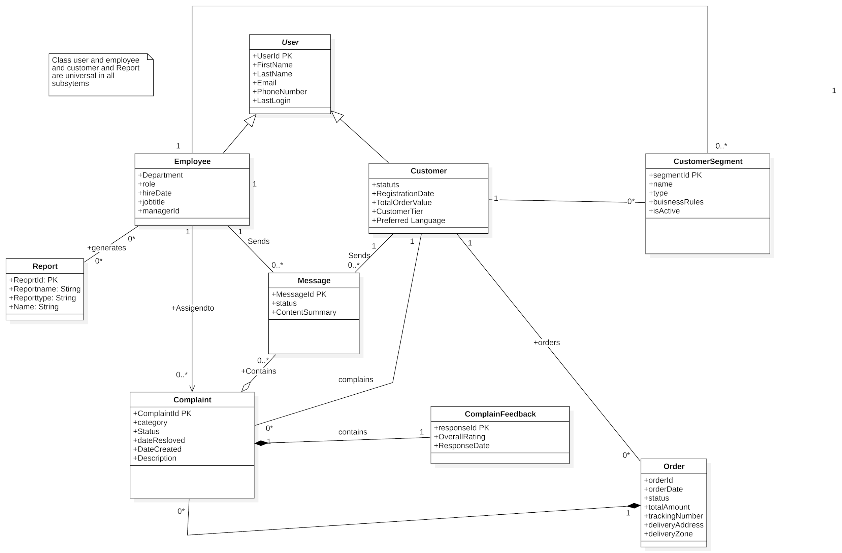
7a. Business Data Model
- 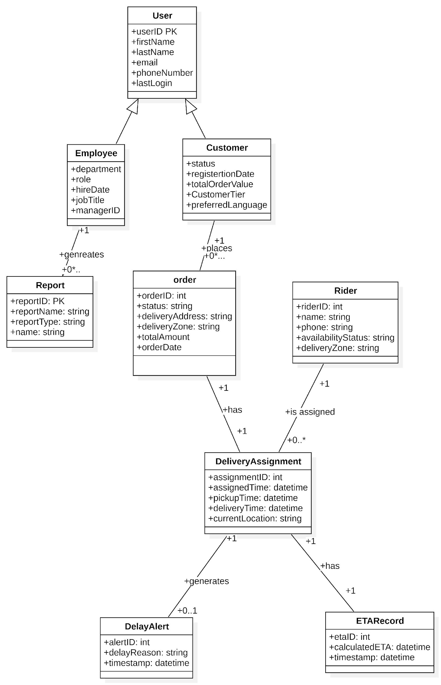

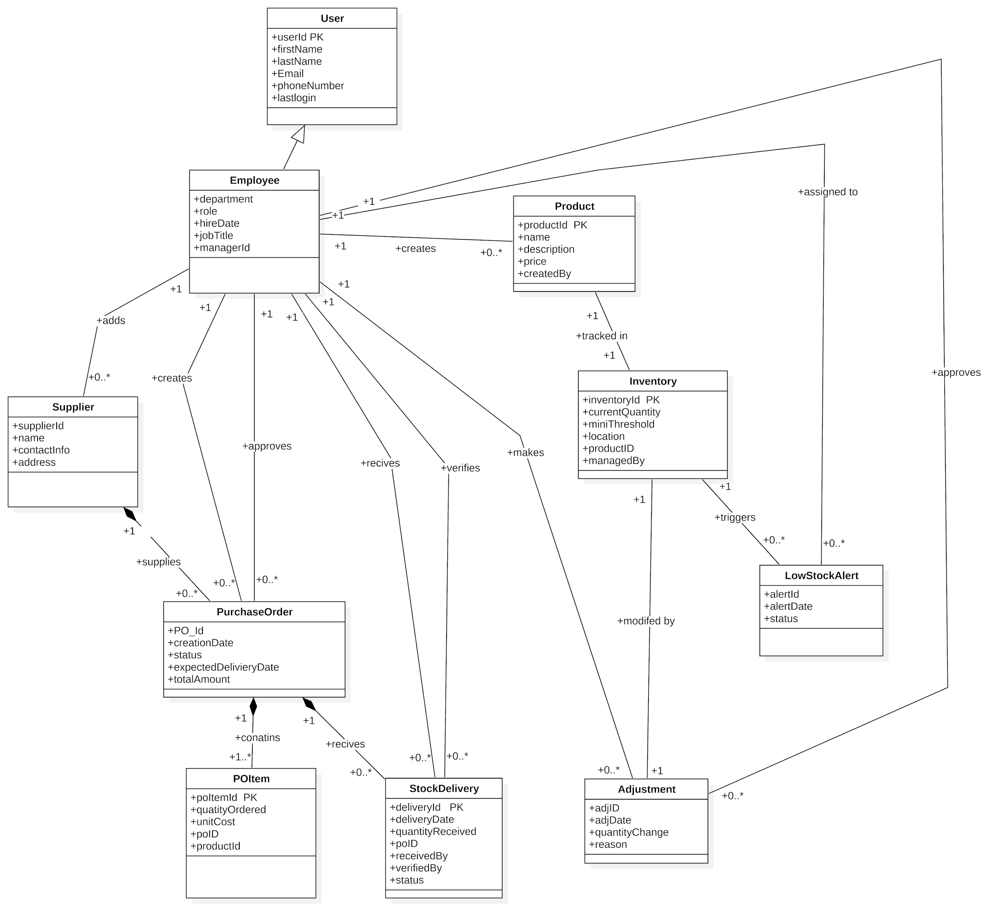

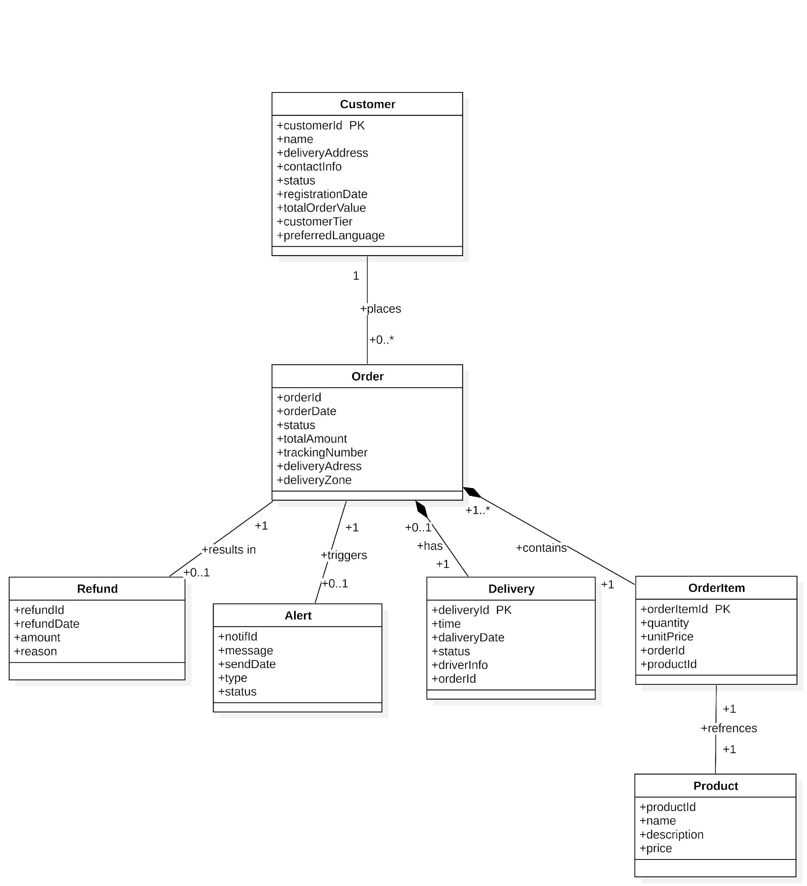

7b. Data Dictionary

- This data dictionary defines the key data entities, their attributes, and relationships for the Breadfast CRM system. It provides an unambiguous definition for all data flows and elements referenced in the requirements, use cases, and models. This serves as the single source of truth for business and technical teams.

Name | Content | Type
Alert | A system-generated notification triggered by a specific state change or condition. | Class
Complaint | A record of a customer issue or grievance that requires tracking and resolution. | Class
Customer | An individual or entity that places orders with Breadfast. A key business entity. | Class
CustomerSegment | A defined group of customers sharing common attributes or behaviors. | Class
Delivery | Represents the fulfillment and logistics process for a specific order. | Class
DeliveryAssignment | The record linking a Rider to a Delivery for a specific Order. | Class
Employee | An internal user of the system (e.g., Agent, Dispatcher, Manager). | Class
ETARecord | A stored Estimated Time of Arrival for a delivery, with a timestamp. | Class
Inventory | The current stock level and status for a specific Product. | Class
LowStockAlert | A specific type of Alert generated when stock falls below a defined threshold. | Class
Message | A communication between a Customer and an Employee. | Class
Order | A customer's request for products, representing a commercial transaction. | Class
OrderItem | A line item detailing the Product and quantity within an Order. | Class
Product | An item sold by Breadfast (e.g., bakery item, grocery). | Class
PurchaseOrder (PO) | A formal request sent to a Supplier to restock Products. | Class
POItem | A line item detailing the Product and quantity within a PurchaseOrder. | Class
Refund | A record of a monetary reimbursement to a customer, often linked to a cancelled Order. | Class
Report | A generated summary of data for analysis, filtered by specific criteria. | Class
Rider | A specific type of Employee responsible for delivering orders. | Class
StockAdjustment | A manual record of a change to inventory levels (e.g., due to damage, count error). | Class
StockDelivery | A record of goods received from a Supplier against a PurchaseOrder. | Class
Supplier | A company that provides Products to Breadfast. | Class
SurveyResponse | Feedback provided by a customer, typically after a resolved complaint or order. | Class
Customer Profile Data | {Customer ID + Customer Name + Email + Phone + Address + Status + Segment Memberships} | Dataflow
Low-Stock Alert | {Alert ID + Product ID + Product Name + Current Quantity + Threshold + Timestamp} | Dataflow
New Support Ticket | {Complaint ID + Customer ID + Order ID (optional) + Description + Timestamp} | Dataflow
Real-Time Dashboard Data | {Total Revenue + Orders Today + Active Deliveries + Open Complaints + Top Products} | Dataflow
Active Status | Enumeration: "Active", "Inactive". Determined by recent activity. | Attribute/Element
Address | The customer's delivery address, including street, city, and zone. | Attribute/Element
Alert ID | System-generated unique identifier (e.g., UUID). | Attribute/Element
Alert Type | Enumeration: "Delivery Delay", "SLA Breach", "Low Stock". | Attribute/Element
Assigned Date/Time | Timestamp when a Delivery was assigned to a Rider. YYYY-MM-DD HH:MM:SS | Attribute/Element
Complaint Description | The detailed text of the issue reported by the customer. | Attribute/Element
Complaint ID | *System-generated unique identifier (e.g., CR-2025-001).* | Attribute/Element
Complaint Status | Enumeration: "New", "In Progress", "Resolved", "Escalated". | Attribute/Element
Current Quantity | *The real-time number of units of a Product in stock. Integer, >= 0.* | Attribute/Element
Customer ID | *System-generated unique identifier (e.g., CUST-10001).* | Attribute/Element
Customer Name | Full name of the customer. String, max 255 characters. | Attribute/Element
Delivery Status | Enumeration: "Assigned", "Picked Up", "In Transit", "Delivered", "Failed". | Attribute/Element
Email | Customer's email address. Must be valid format. | Attribute/Element
Employee ID | *System-generated unique identifier for staff (e.g., EMP-2001).* | Attribute/Element
Employee Role | Enumeration: "Support Agent", "Dispatcher", "Manager", "Admin". | Attribute/Element
Estimated Delivery Time | The predicted time of delivery. YYYY-MM-DD HH:MM:SS | Attribute/Element
Message Body | The content of the communication. Text. | Attribute/Element
Order ID | *System-generated unique identifier (e.g., ORD-30001).* | Attribute/Element
Order Status | Enumeration: "Received", "Preparing", "Ready", "Out for Delivery", "Delivered", "Cancelled". | Attribute/Element
Phone | Customer's primary contact number. String. | Attribute/Element
Product ID | *System-generated unique identifier for a product (e.g., PROD-5001).* | Attribute/Element
Product Name | Name of the product. String, max 255 characters. | Attribute/Element
Product Status | Enumeration: "In Stock", "Low Stock", "Out of Stock". | Attribute/Element
Purchase Order ID | *System-generated unique identifier (e.g., PO-4001).* | Attribute/Element
Quantity | The number of units in an OrderItem or POItem. Integer, > 0. | Attribute/Element
Re-order Threshold | The minimum stock level that triggers a LowStockAlert. Integer. | Attribute/Element
Resolution Notes | Text documenting how a Complaint was resolved. | Attribute/Element
Rider ID | A unique identifier for a Rider, which is a subset of Employee ID. | Attribute/Element
Segment Name | A descriptive name for a customer group (e.g., "High-Value", "Frequent Buyers"). | Attribute/Element
SLA Deadline | The timestamp by which a Complaint should be resolved. YYYY-MM-DD HH:MM:SS | Attribute/Element
Supplier ID | *System-generated unique identifier (e.g., SUP-6001).* | Attribute/Element
Timestamp | The date and time an event occurred. YYYY-MM-DD HH:MM:SS | Attribute/Element
Total Amount | The monetary value of an Order or Refund. Decimal, 2 decimal places. | Attribute/Element

8. The Scope of the Product

8a. Product Boundary

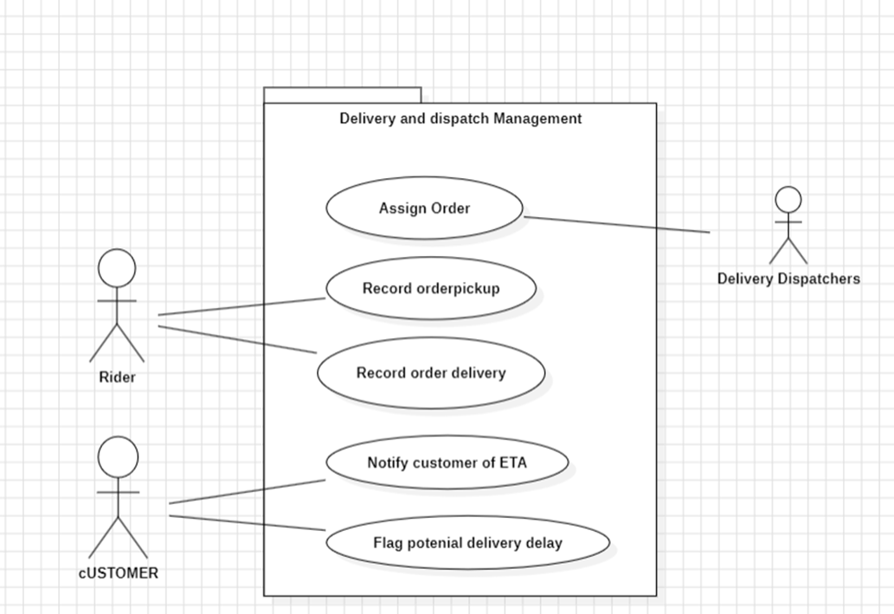

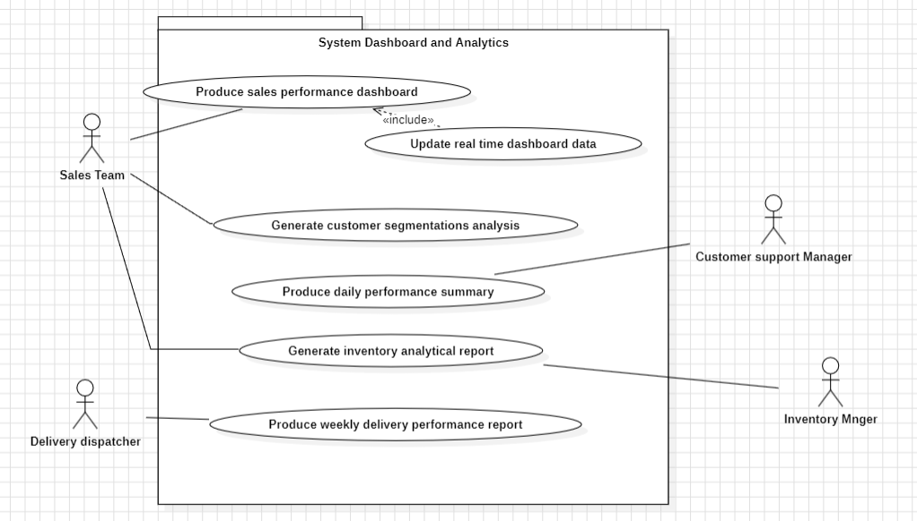

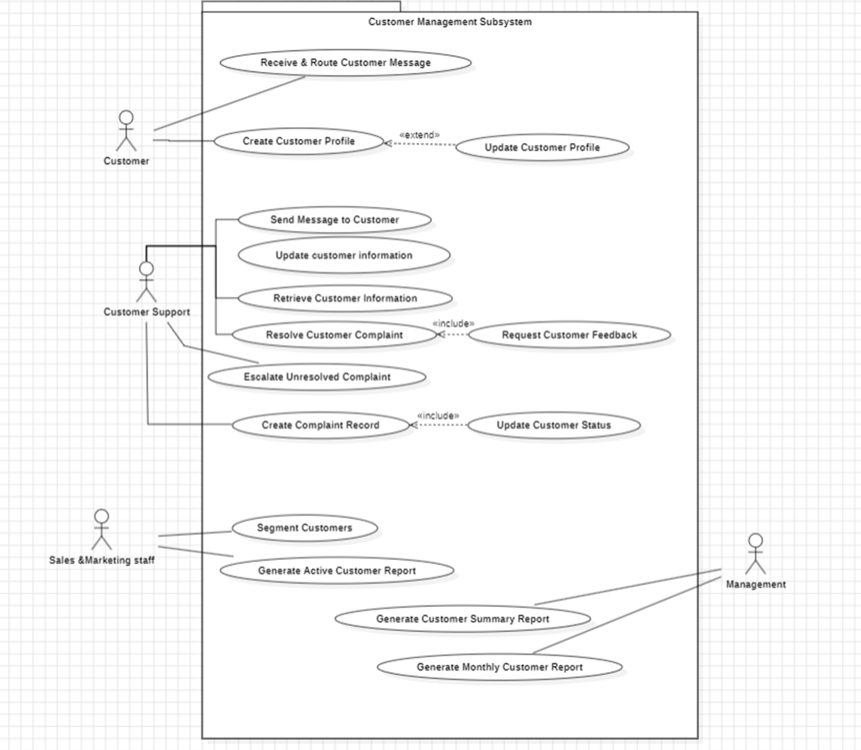

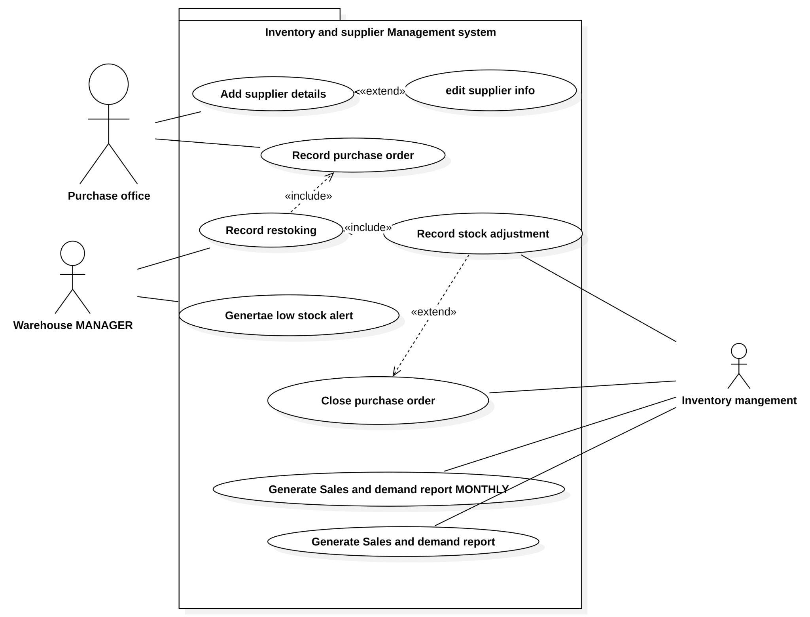

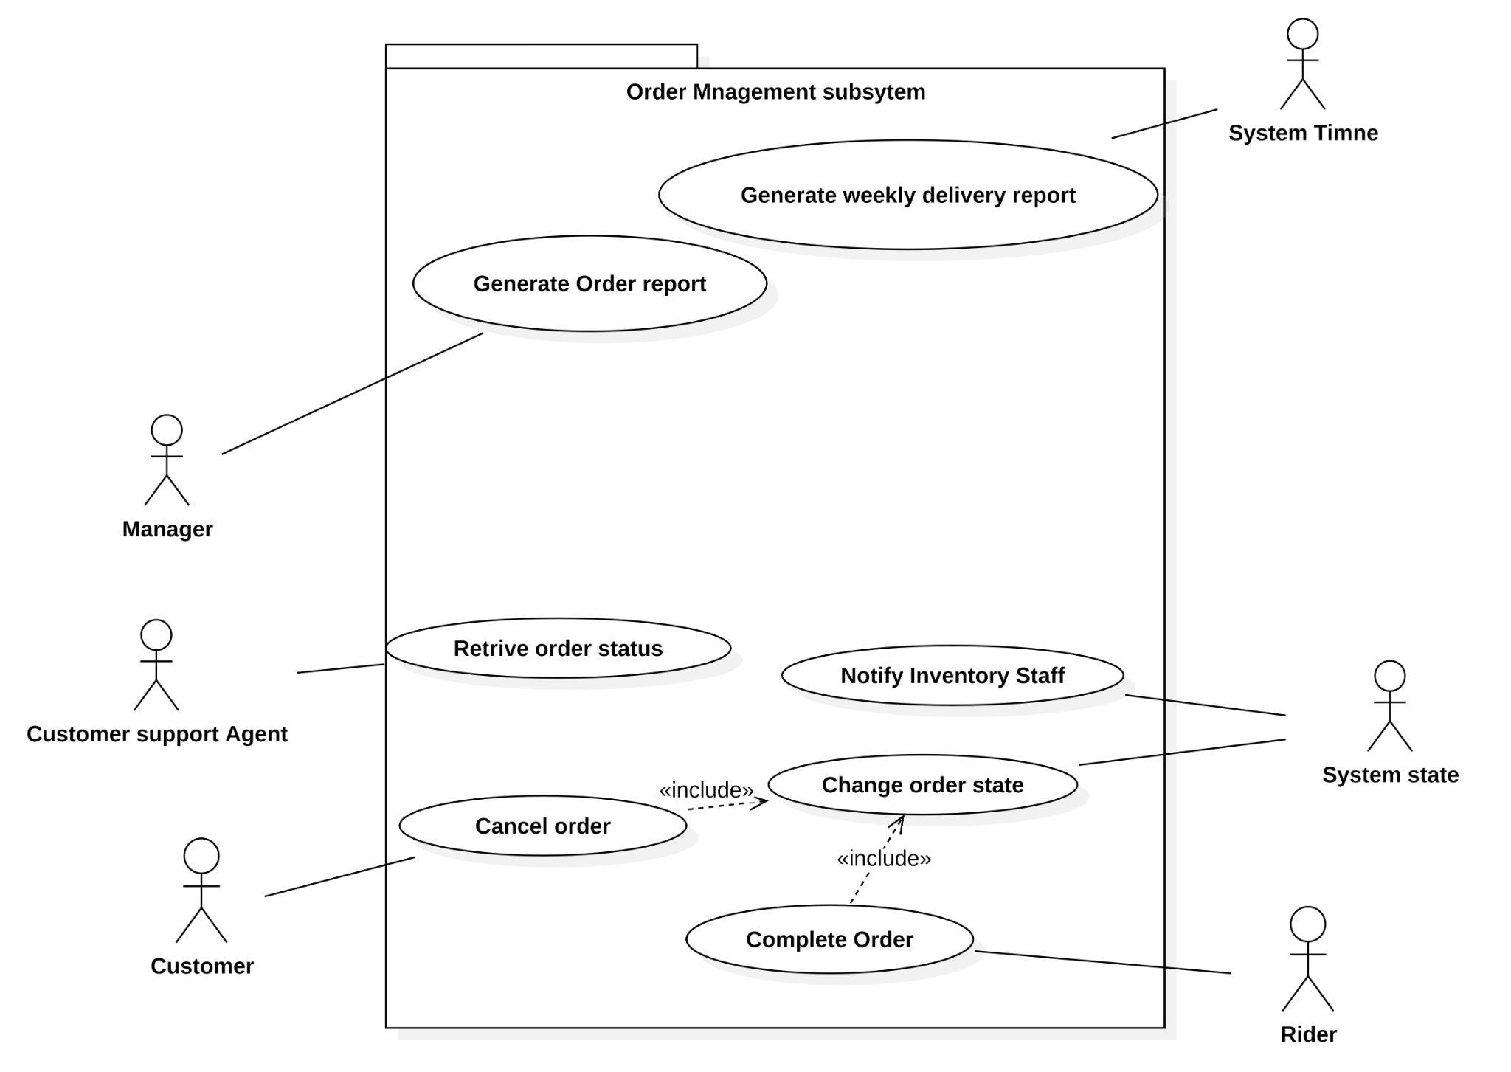

8b. Product Use Case Table

System analytics dashboard Management system

Use Case Name | Brief Description
Produce Sales Performance Dashboard | The system retrieves and displays key sales metrics (revenue, orders, top products) in a unified dashboard view upon user request.
Generate Inventory Analytical Report | The system creates a tailored report with charts and summaries based on user-selected filters like date range, product category, or region.
Generate Customer Segmentation Analysis | The system groups customers into segments (e.g., high-value, frequent buyers) based on defined rules and displays the results for analysis.
Produce Daily Performance Summary | The system automatically compiles and formats a summary report of the day's sales, delivery, and inventory data at a scheduled time.
Update Real-Time Dashboard Data | The system automatically polls the database at regular intervals and refreshes all dashboard visualizations with the latest data.
Produce Weekly Delivery Performance Report | The system automatically calculates and generates a report on delivery metrics (times, success rates) for the previous week at a scheduled time.

Customer Management system:

Use Case Name | Brief Description
Create Customer Profile | The system captures registration details and stores a new customer record in the database when a new account is created.
Update Customer Information | The system validates and saves modified personal data when customer information is edited by support staff.
Retrieve Customer Information | The system searches for and displays complete customer records based on lookup criteria entered by support agents.
Segment Customers | The system organizes customers into dynamic groups using filters such as region, purchase frequency, and total spending.
Generate Customer Summary Report | The system produces a summarized report of customer data based on management-selected filters for analysis purposes.
Generate Monthly Customer Report | The system automatically compiles monthly customer activity statistics on a scheduled date and time.
Generate Active Customer Report | The system generates a weekly list of active customers based on recent activity and engagement metrics.
Update Customer Status | The system updates the customer’s status (e.g., Active → Inactive) based on behavior or detected inactivity rules.
Receive & Route Customer Message | The system accepts incoming customer messages and routes them to the appropriate support agents for handling.
Send Message to Customer | The system enables support agents to send responses or follow-up messages to customers directly from the dashboard.
Resolve Customer Complaint | The system marks support tickets as resolved and updates complaint history when an agent finishes handling the issue.
Update Customer Profile | The system applies changes to stored profile attributes when updates are performed by customers or support agents.
Request Customer Feedback | The system automatically sends customer satisfaction surveys after complaints or issues have been resolved for a set duration.
Create Complaint Record | The system creates a new complaint ticket when a customer submits an issue or message requiring escalation.
Escalate Unresolved Complaint | The system detects overdue complaints that exceeded the SLA deadline and automatically escalates them to higher support levels.

Order Management system:
Use Case Name | Brief Description
Retrieve Order Status | Provides real-time tracking and status details of a customer order.
Generate Order Report | Produces filtered analytics on orders based on manager-selected criteria.
Cancel Order | Marks the order as cancelled and triggers a refund if applicable.
Generate Weekly Delivery Report | Summarizes weekly delivery performance every Sunday morning.
Change Order State | Updates the state of an order based on internal system or dispatcher input.
Complete Order | Marks an order as delivered and logs it into order history.
Notify Inventory Staff | Alerts staff when item stock is insufficient during checkout.

Delivery and dispatch:

Use Case Name | Brief Description
Assign Order to Rider | The system automatically assigns a "Ready" order to an available rider based on predefined rules (proximity, workload).
Record Order Pickup | The system updates the order status to "Picked Up," records the timestamp, and may trigger a customer notification.
Record Order Delivery | The system updates the order status to "Delivered," records the timestamp, and finalizes the order lifecycle.
Notify Customer of ETA | The system automatically calculates and sends an estimated delivery time to the customer via their preferred channel.

Inventory and supplier Management system:
Use Case Name | Brief Description
Add Supplier Details | The system records supplier information (name, contact, related products) and stores it in the supplier database.
Edit Supplier Information | The system retrieves an existing supplier record, applies updates, and saves the modified data.
Record Purchase Order | The system registers a new purchase order with supplier, items, quantities, and expected delivery details.
Record Restocking | The system updates inventory levels when goods are received and marks the corresponding purchase order as fulfilled or partial.
Record Stock Adjustment | The system allows authorized users to adjust stock levels and logs the reason (e.g., damage, returns, manual count).
Generate Inventory / Restocking Report | The system automatically compiles stock data and generates daily or weekly reports summarizing stock status and restocking needs.
Generate Sales and Demand Report | The system analyzes past sales and restocking patterns and produces demand forecasts.
Generate Low-Stock Alert | The system automatically triggers a low-stock notification when a product’s quantity falls below a predefined threshold.
Close Purchase Order | The system marks the purchase order as completed when all items have been received and archives it into restocking history.

9. Functional Requirements

9a. Functional Requirements
Format Legend:
- Source: Traceability to originating User Story (US) or Event.
Customer Management System:

Event/Use Case | Description | Rationale | Source | Fit Criterion
Retrieve Customer Information | The system shall allow searching for customers by name, email, or phone number. | To enable agents to quickly find customer profiles. | US: View Customer Profile | When an agent enters a valid name, email, or phone number, the system returns matching customer records within 2 seconds.
Retrieve Customer Information | The system shall display search results sorted alphabetically by customer name. | To allow for quick scanning of results. | US: View Customer Profile | The list of customers in the search results is displayed in ascending alphabetical order (A-Z) by the Customer Name attribute.
Retrieve Customer Information | The system shall display a complete customer profile, including personal details, contact info, past orders, and complaint records, in a unified view. | To provide a 360-degree view of the customer for accurate support. | US: View Customer Profile | The customer profile screen contains dedicated, populated sections for Personal Details, Contact Info, Order History, and Complaint History.
Update Customer Information | The system shall allow authorized agents to edit fields marked as editable (e.g., contact phone, delivery preferences). | To keep customer data accurate and up-to-date. | US: Edit Customer Info | An agent can change the value in an authorized field and save the change successfully.
Update Customer Information | The system shall prevent unauthorized agents from editing restricted fields (e.g., payment information, purchase history). | To maintain data integrity and security. | US: Edit Customer Info | When an unauthorized agent attempts to edit a restricted field, the input control is disabled or read-only.
Update Customer Information | The system shall log all changes to customer data, including the timestamp and the ID of the agent who made the change. | For audit trail and compliance. | US: Edit Customer Info | For every update, a new record is created in the AuditLog table with the changed fields, new values, Agent ID, and Timestamp.
Receive & Route Message | The system shall create a new message record and link it to the customer's profile when a message is received via an integrated channel. | To maintain a complete communication history. | US: Send/Receive Messages | A new entry appears in the customer's message history immediately after a message is received from an external channel (e.g., WhatsApp, in-app chat).
Send Message to Customer | The system shall allow an agent to compose and send a message to a customer directly from the CRM dashboard. | To handle customer communication without switching apps. | US: Send/Receive Messages | An agent can select a customer, type a message in the dashboard interface, and upon sending, the message is delivered to the customer's preferred channel.
Resolve Customer Complaint | The system shall allow an agent to change the status of a complaint to "Resolved." | To track the completion of support tasks. | US: Track Complaint Status | From a complaint with status "New" or "In Progress," an agent can select "Resolved" from a dropdown and save the change.
Track Complaint Status | The system shall automatically record the time elapsed between a complaint's creation and its resolution. | To measure support efficiency and SLA compliance. | US: Track Complaint Status | The system calculates and stores the difference between the Resolved Timestamp and Created Timestamp for every complaint.
Track Complaint Status | The system shall send a notification if a complaint remains in a non-"Resolved" status for more than 24 hours. | To proactively escalate potential delays. | US: Track Complaint Status | A dashboard alert is generated for any complaint where the Current Timestamp minus Created Timestamp is greater than 24 hours and Status != "Resolved".
Segment Customers | The system shall allow a sales user to filter customers based on purchase frequency, total spending, and preferred product categories. | To enable targeted marketing campaigns. | US: Create Customer Segments | The user interface provides filter controls for Orders Count, Total Spend, and Product Category which, when applied, dynamically update the displayed list of customers.

Order Management Subsystem:
Event/Use Case | Description | Rationale | Source | Fit Criterion
Retrieve Order Status | The system shall display the current status (e.g., Preparing, Out for Delivery) and the last updated timestamp for a given order. | To provide agents and customers with accurate, real-time order information. | US: Check Order Status | The order details page for any order shows the Order Status and Last Updated Timestamp fields.
Retrieve Order Status | The system shall display the name and contact information of the assigned rider if the order status is "Out for Delivery" or similar. | To facilitate coordination for delayed deliveries. | US: Check Order Status | When Order Status is "Out for Delivery," the Rider Name and Rider Phone fields are visible on the order details page.
Retrieve Order Status | The system shall display a history of status changes for an order, with timestamps for each change. | To provide a full audit trail of the order's progress. | US: Check Order Status | A "Status History" section on the order details page lists all previous statuses (e.g., Received -> Preparing -> Ready) with the exact time of each transition.
Cancel Order | The system shall allow a customer or agent to cancel an order if its current status is "Received" or "Preparing". | To honor cancellation requests before significant resources are committed. | US: Cancel Order | The "Cancel Order" button is active and functional only when Order Status is "Received" or "Preparing".
Cancel Order | The system shall initiate a refund process when an order is cancelled. | To ensure customers are reimbursed for cancelled orders. | US: Cancel Order | Upon successful cancellation, a new Refund record is created with Status = "Pending" and linked to the cancelled order.
Change Order State | The system shall allow a dispatcher or kitchen staff to update the order status according to a predefined lifecycle (e.g., Preparing -> Ready for Pickup). | To track the order through its fulfillment stages. | Event: Order is Ready for Delivery | An authorized user can select a new status from a predefined list, and upon saving, the Order Status and Last Updated Timestamp are updated.

Inventory and Supplier Management Subsystem
Event/Use Case | Description | Rationale | Source | Fit Criterion
Track Stock Levels | The system shall display the current quantity, stock status (In Stock, Low, Out of Stock), and last restocked date for each product on the inventory dashboard. | To give inventory managers an immediate overview of stock health. | US: Track Stock Levels | The inventory dashboard grid includes columns for Current Quantity, Stock Status, and Last Restocked Date for every product.
Generate Low-Stock Alert | The system shall automatically change a product's status to "Low Stock" when its Current Quantity falls below its Re-order Threshold. | To provide a clear visual indicator of items needing restocking. | Event: Inventory Level Falls Below Threshold | The Stock Status field for a product updates  to "Low Stock" within 1 minute of its Current Quantity being saved  at a value less than its Re-order Threshold.
Generate Low-Stock Alert | The system shall create a LowStockAlert record and display it on the inventory dashboard when a low-stock condition is detected. | To proactively notify staff. | Event: Inventory Level Falls Below Threshold | A new alert appears  in a dedicated "Alerts"  panel on the dashboard when the condition in FR-INV-002 is met.
Add Supplier Details | The system shall allow a purchasing officer to create a new supplier record by entering name, contact information, and associated products. | To maintain a master list of suppliers for procurement. | US: Add/Edit Supplier | The user can navigate to a "New Supplier" form, input data into the required fields, and save, resulting in a new record in the Supplier table.
Record Purchase Order | The system shall allow a purchasing officer to create a purchase order (PO) by selecting a supplier and adding products with quantities. | To formalize the restocking process. | US: Record Purchase Order | The user can create a new PO, link it to a Supplier, add multiple Product lines with Quantity, and save it with a status of "Pending".
Record Restocking | The system shall allow warehouse staff to update inventory quantities by confirming receipt of goods against a Purchase Order. | To accurately reflect received stock in the system. | US: Record Restocking | A user can select an open PO, mark line items as received, and the system updates the Current Quantity for each received product.

Delivery & Dispatch Management Subsystem
Event/Use Case | Description | Rationale | Source | Fit Criterion
Assign Order to Rider | The system shall automatically suggest available riders for a "Ready" order based on proximity to the pickup location and current workload. | To optimize delivery efficiency. | US: Assign Order to Rider | The dispatch interface, when an order is ready, displays a list of riders sorted by proximity (closest first) and with fewer than 3 active deliveries.
Record Order Pickup | The system shall update the order status to "Picked Up" and record the timestamp when a rider confirms pickup. | To accurately track the delivery lifecycle. | US: Record Order Pickup | When a rider clicks "Picked Up" in the rider app, the linked Order Status changes to "Picked Up" and the Picked Up Timestamp is set.
Record Order Delivery | The system shall update the order status to "Delivered" and record the timestamp when a rider confirms delivery. | To finalize the order and record successful completion. | US: Record Order Delivery | When a rider clicks "Delivered" in the rider app, the linked Order Status changes to "Delivered" and the Delivered Timestamp is set.
Notify Customer of ETA | The system shall automatically send an ETA notification to the customer via their preferred channel 2 minutes after an order is marked "Picked Up". | To keep the customer informed and improve satisfaction. | Event: Time to Send ETA | A message is queued for delivery to the customer 120 seconds after the Picked Up Timestamp is recorded.
Flag Potential Delay | The system shall create a DelayAlert if the current time exceeds the Estimated Delivery Time for an order with status "In Transit". | To proactively identify and manage delayed deliveries. | Event: Delivery Taking Longer | An alert is generated if Order Status is "In Transit" and the system time is greater than the Estimated Delivery Time.

Analytics & Reporting Subsystem
Event/Use Case | Description | Rationale | Source | Fit Criterion
Produce Sales Performance Dashboard | The system shall display real-time total revenue, number of orders, and average order value for the current day. | To provide a high-level snapshot of sales performance. | US: View Sales Dashboard | The sales dashboard shows calculated values for Total Revenue, Orders Count, and Average Order Value that update within 5 minutes of a new order being placed.
Produce Sales Performance Dashboard | The system shall list the top 5 best-selling and bottom 5 worst-selling products for a selected date range. | To identify product trends. | US: View Sales Dashboard | When a user selects a date range and clicks "Apply," two lists are generated: one with the 5 products with the highest Quantity Sold and one with the 5 products with the lowest.
Generate Customer Segmentation Analysis | The system shall dynamically update customer segment memberships (e.g., "High-Value") as new orders are placed. | To ensure segments are always based on the most current data. | US: Create Customer Segments | A customer's membership in the "High-Value" segment (Total Spend > $500) is re-evaluated and updated within 1 hour of them placing a new order.

Techniques Used
- Stakeholder interviews
- Questionnaires
- Review of current documentation
- Industry research
Supporting Materials
Breadfast CRM Internal User Questionnaire:
This questionnaire is being sent to all internal operational staff. As you know, Breadfast is developing a new integrated CRM system to streamline our operations and improve customer service.
The purpose of this questionnaire is to obtain preliminary information to assist in defining the requirements for the new system. Follow-up discussions will be held to permit everybody to elaborate on their needs and ideas.

Part I. Please answer these questions based on a typical workday
- On average, how many customer inquiries (calls, chats, emails) do you handle per day? _______________
- How many different systems or screens do you need to open to resolve a single customer issue? ______
- How many times per day do you have to contact another department (e.g., call Delivery, email Warehouse) to get information for a customer? ___________________________________
- Estimate the percentage of your shift spent on manual data entry or updating records in multiple places. ______%
- How many times per day do you encounter issues due to outdated or incorrect order status information? _________________________________________
- For delivery teams: How many orders are typically reassigned manually per shift due to inefficiencies? ________
Part II. Circle the appropriate number on the scale from 1 to 7 based on how strongly you agree or disagree with the statement.
Question | Strongly Agree Strongly Disagree
It would help me do my job better to have a single, unified view of all customer information (profile, order history, communications). | 1 | 2 | 3 | 4 | 5 | 6 | 7
A real-time dashboard showing order status from kitchen to delivery would significantly reduce customer complaints. | 1 | 2 | 3 | 4 | 5 | 6 | 7
Having all customer communication (email, chat, call) in one place would make me more efficient. | 1 | 2 | 3 | 4 | 5 | 6 | 7
Automated low-stock alerts would help prevent issues with customer orders. | 1 | 2 | 3 | 4 | 5 | 6 | 7
A system that automatically assigns delivery riders based on location and workload would improve delivery times. | 1 | 2 | 3 | 4 | 5 | 6 | 7
The current process for finding basic customer or order information is slow and frustrates both me and the customer. | 1 | 2 | 3 | 4 | 5 | 6 | 7

Internal Executive Interview — Breadfast CRM System
Role Interviewed: Operations Manager (Internal Executive).

- How satisfied are you with the current process of managing orders
How do you currently manage and oversee the end-to-end process of order handling and delivery operations?
(Please describe your workflow from order placement to successful delivery.)
- What specific information or inputs do you and your team need to start your daily operations, and what outputs or reports do you generate?
- How satisfied are you with the current process of managing orders and deliveries?
☐ Very satisfied ☐ Somewhat satisfied ☐ Neutral ☐ Dissatisfied ☐ Very dissatisfied
- What are the most common challenges you and your team face during the daily delivery and coordination process?
- What manual or repetitive tasks take up most of your team’s time and should be automated in the new CRM system?
- What specific CRM features do you believe would most improve coordination between Customer Support, Delivery, and Operations?
- Should all departments have full access to customer and order data, or should access be role-based?
☐ Full access for all ☐ Role-based access only ☐ Not sure
Why?
- What types of dashboards or reports would help you make faster, data-driven operational decisions?
- In your view, what would define a successful CRM system implementation six months after launch?
Analysis:
The system vision identified major problems in the current Breadfast operations, including fragmented customer and order data, lack of real-time visibility across departments, manual rider assignment, and absence of integrated analytics for management. These issues lead to delays, inefficient operations, and poor customer support performance.
The user stories and stakeholder inputs showed a clear need for a unified CRM platform that integrates customer management, order tracking, delivery and dispatch, inventory management, and sales analytics into one system.
The event decomposition and subsystem breakdown confirmed that these needs can be logically organized into five main modules: Customer Management, Order Management, Delivery & Dispatch, Inventory & Supplier Management, and Sales & Analytics.
Therefore, the functional requirements and use cases defined in the project were derived directly from the identified problems and stakeholder needs, ensuring that the proposed CRM system addresses Breadfast’s operational inefficiencies and supports better decision-making and customer service.

Non-functional Requirements
The following sections 10-17 describe the non-functional requirements. The form of these requirements is the same as for the functional requirements as described in section 9 above.

10. Look and Feel Requirements

10a. Appearance Requirements

The appearance of the Breadfast CRM shall reflect the corporate identity of Breadfast and visually support the workflows of internal operational users. The interface shall maintain a clean, minimal, white + purple color scheme consistent with Breadfast’s brand direction. The design should avoid clutter, minimize visual noise, and offer clear hierarchy through spacing, typography, and component layout.

Rationale / Motivation

To ensure the CRM visually aligns with Breadfast’s internal brand and maintains consistency across all internal tools. The appearance must support the busy, high-pressure environment of users such as customer support agents, dispatchers, and inventory managers by being easy to scan, visually calming, and efficient.

Requirements

AR-1: Branding Colors

The product shall use the Breadfast CRM branding palette:

Primary background: White

Accent color: Purple tone

Neutral secondary tones: Light greys

Action elements: Accent color or dark neutral depending on mode

AR-2: Minimal, B-Style Visual Design

The interface shall reflect a minimal, modern “B-design” Breadfast style, emphasizing:

Flat UI components

Rounded corners

High readability

Minimal decorative elements

AR-3: Desktop-First Layout

The product shall be designed for desktop-first usage, with responsive support for optional tablet use but not optimized for mobile primary use.

AR-4: Consistent Iconography & Typography

All icons, text sizes, and UI elements shall be consistent across all CRM modules (Customer Support, Delivery Dispatching, Inventory, Purchasing, Sales dashboards).

AR-5: Light and Dark Mode Appearance

The interface shall provide both light and dark modes, maintaining the Breadfast pink-purple accent color and all contrast ratios.

Fit Criteria

Branding Verification
The design shall pass a review by Breadfast’s operations and brand team confirming compliance with the white + purple-pink palette and minimal style.

User Visual Clarity Test
In usability testing:

80% of Customer Support Agents shall report that the interface is visually clear and uncluttered.

80% of Delivery Dispatchers shall confirm that dashboards are readable without visual distractions.

80% of Inventory Managers shall confirm that table layouts and forms are easy to read.

Mode Validation
Light/Dark mode must achieve at least WCAG AA contrast rating for all primary UI components.

Desktop-First Verification
All major screens (Customer profile, Dispatch dashboard, Inventory screens) shall render correctly at 1366×768 and above, without clipped content.

Considerations

Appearance must remain consistent across CRM modules even though user roles differ.

Pinkish-purple color must be used tastefully as an accent — not overwhelming or distracting for dispatchers who rely on real-time data.

Light and dark mode differences must not break hierarchy or screen flow.

10b. Style Requirements

The style of the Breadfast CRM shall communicate professionalism, clarity, trust, and operational speed. It must reflect Breadfast’s identity as a fast-moving logistics and commerce company while supporting the high-pressure workflows of internal teams.

Desired Style Keywords

Clean

Minimal

Professional

Fast-moving

Calm under pressure

Efficient

Adaptable (light/dark)

Motivation

After functional requirements, the product’s style and feel strongly influence user satisfaction and efficiency. Customer Support Agents and Dispatchers work under time-sensitive conditions; the system must feel reliable, fast, and non-overwhelming.

Requirements

SR-1: Professional & Trustworthy Appearance

The CRM must feel reliable and stable to internal teams, especially Customer Support and Dispatchers. No playful or overly casual design elements may be used.

SR-2: Calm User Experience

The system shall use soft tones, gentle animations, and smooth transitions to prevent cognitive overload for users dealing with customers or time-critical deliveries.

SR-3: Fast-Moving Interaction Style

The interface shall respond to user actions within 200ms for navigation and 500ms for data refreshes, reinforcing the speed expected in Breadfast operations.

SR-4: Consistency Across Modules

Whether the user is in customer support, dispatch, inventory, or sales analysis, the style must remain visually unified.

SR-5: Clear Hierarchy & Reduced Cognitive Load

Primary actions must be clearly distinguishable using the accent color, while secondary actions remain minimal and neutral.

SR-6: Adaptive Mood in Light/Dark Mode

Light mode should feel clean and energetic;
Dark mode should feel focused and calm.

Fit Criteria

User Trust Survey
After first use, 70% of representative internal stakeholders (Support, Dispatch, Inventory) shall agree the system feels:

trustworthy

professional

visually comfortable

Cognitive Load Test
In usability trials, 90% of test users should be able to complete their daily workflows without asking where buttons or actions are located.

Speed Responsiveness Test
Using system logs:

95% of UI interactions must complete within the specified response times (200ms navigation / 500ms refresh).

Style Consistency Review
A design audit must confirm consistency in:

Buttons

Spacing

Typographic hierarchy

Color usage

Component shapes

Considerations

Different stakeholders have different stress levels:
dispatchers need real-time clarity,
support agents need fast profile loading,
inventory managers need readable tables.
Style must support all without compromising cleanliness.

Avoid dark-purple-heavy designs in dark mode; maintain neutrality.

Users shift between multiple CRM modules; inconsistency will decrease productivity.

11. Usability and Humanity Requirements

11a. Ease of Use Requirements

Requirement Description

The Breadfast CRM shall be easy to use for all internal operational stakeholders. Interfaces must support high-pressure, time-sensitive workflows (Customer Support, Dispatch, Inventory) with minimal cognitive load, efficient navigation, and clear feedback. The product should reduce errors, minimize clicks, and help users locate information rapidly.

Ease-of-Use Properties

EU-1: Efficiency of Use

The system shall allow high-frequency users (Support Agents, Dispatchers, Inventory Managers) to complete daily actions with minimal steps and rapid navigation.

EU-2: Ease of Remembering

Casual or secondary users (Sales, Purchasing) shall be able to return after long gaps and still operate key features without relearning.

EU-3: Error Prevention

The CRM shall guide users to avoid common errors, especially during:

creating customer profiles

updating orders

assigning riders

entering stock levels

approving supplier POs

EU-4: Immediate Feedback

The system shall provide instant visual confirmation for actions like saving, updating, assigning, deleting, or escalating.

EU-5: High User Satisfaction

Interfaces shall feel responsive, modern, and not frustrating during multitasking or peak load.

Motivation

To help all Breadfast employees—especially Support and Delivery teams working under pressure—operate efficiently with fewer mistakes and faster resolution times.

Fit Criteria

Efficiency Tests

Customer Support Agents must complete the workflow “open customer profile → update issue → log resolution” in ≤ 20 seconds for 80% of test users.

Delivery Dispatchers must assign a rider to an order in ≤ 10 seconds in 90% of test cases.

Memory & Retention Test

70% of Sales & Purchasing users returning after a 2-week gap must complete their primary workflow without assistance.

Error Rate Reduction

During one month of operation, workflow error rates (invalid submissions, missing fields, incorrect selections) shall be < 2%.

Satisfaction Survey

At least 80% of users shall report that the CRM is “easy” or “very easy” to use after 3 weeks.

Feedback Verification

All actions shall generate confirmation feedback within 300ms (toast, highlight, animation, status update).

Considerations

Customer Support interacts with angry/urgent customers; usability directly affects service quality.

Dispatchers rely heavily on speed and real-time accuracy—visual delays cause real operational failure.

Inventory Managers need extremely clear data entry screens due to stock sensitivity.

11b. Personalization & Internationalization Requirements

Requirement Description

The CRM shall support personalization of interface settings and internationalization features relevant to Breadfast’s operations (Arabic/English support, date formats, time zones). Users should be able to configure their preferred viewing mode and convenience settings.

Requirements

PI-1: Language Support

The system shall support English initially and allow expansion to Arabic if required by Breadfast.

PI-2: Regional Formatting

Dates, numbers, and currencies shall conform to MENA region formatting standards.

PI-3: User Interface Personalization

Each user can configure:

Light or Dark mode

Table column visibility

Dashboard widget arrangement

Notification preferences (sound, pop-up, silent)

PI-4: Saved User Preferences

The system shall store user preferences and reapply them on every login.

PI-5: Role-Based UI

The CRM shall adjust UI complexity based on role:

Customer Support sees quick-access issue tools

Dispatchers see live-location dashboards

Inventory Managers see stock tables

Admins see permission and user management

Motivation

To avoid forcing users from different departments or cultures into a single rigid layout or language style and to reduce operational friction.

Fit Criteria

In usability testing, 80% of users must successfully configure at least two preferences (theme + dashboard layout).

UI text and labels must display correctly in selected language without layout breaks.

All saved preferences must persist across 10 consecutive logins without reset.

Considerations

Breadfast operates in Egypt: English is default; Arabic may be a phase-two requirement.

Personalization greatly impacts satisfaction for users working 8-hour shifts.

11c. Learning Requirements

Requirement Description

The CRM shall be easy to learn for all user categories. Training time varies by role and complexity but must remain minimal due to high operational turnover (Support & Dispatch teams). Common workflows must be learnable without manuals.

Requirements

LR-1: Quick Learning for Core Users

Customer Support Agents and Dispatchers shall be able to operate essential features after short training.

LR-2: Minimal Training for Secondary Users

Sales, Riders, and Purchasing officers shall learn their module with minimal guidance.

LR-3: Built-In Learning Aids

The CRM shall include:

tooltip explanations

onboarding hints

short “guided steps” for complex workflows

clear error messages with how-to-fix guidance

LR-4: Module Familiarity

Each module (Support, Dispatch, Inventory) must be logically consistent with the others to reduce learning barriers.

Motivation

Training time is costly. Breadfast’s fast-moving operations require quick onboarding for new support agents and dispatchers.

Fit Criteria

Training Duration

Customer Support agents must reach baseline productivity (handling a customer profile and creating a complaint case) within 1 hour of training.

Dispatchers must be able to assign riders and view live orders within 2 hours of training.

Public/Zero Training Tasks

Riders shall update delivery statuses without any training.

Onboarding Success

80% of new users shall complete the onboarding tutorial without external help.

Error-Free Completion

75% of first-time users must complete set workflows without major errors.

Considerations

Refer to 2d: Some users (Support, Dispatch) handle stressful situations and need extremely straightforward learning curves.

11d. Understandability and Politeness Requirements

Requirement Description

The product shall use terminology, metaphors, and workflows that match the operational reality of Breadfast teams. It must not expose technical system terminology or require users to understand backend processes.

Requirements

UP-1: Use Familiar Operational Language

The system shall use words used daily inside Breadfast such as:

“Assign Rider” instead of “Link entity”

“Create Issue” instead of “Open Case Object”

“Stock Count” instead of “Inventory Reconciliation Batch”

UP-2: Hide Technical Complexity

The CRM shall hide internal database/technical structures (IDs, raw timestamps, table names).

UP-3: Auto-Fill Where Possible

If the system already knows information (user ID, timestamp, rider name), it must not ask the user again.

UP-4: Meaningful Notifications

Messages must be polite, clear, and actionable (e.g., “Order cannot be assigned because the rider is already busy,” instead of cryptic errors).

Motivation

Users must feel the system understands their world, not the developers’ world. Understandability increases adoption and reduces training time.

Fit Criteria

80% of users shall report that system terminology matches their day-to-day language.

During observation, duplicate or unnecessary input fields must be reduced to zero cases.

Error messages must include a reason and a suggestion for at least 90% of system validations.

Considerations

Each department has its own language style; CRM must unify without confusing users.
Avoid technical language like "foreign key", "session timeout", "API payload".

11e. Accessibility Requirements

Requirement Description

The CRM shall be accessible to Breadfast employees with common visual, motor, or cognitive limitations. It must comply with accessibility guidelines appropriate for internal enterprise systems.

Requirements

AC-1: Color Accessibility

UI must consider color-blind users (especially red-green blindness). The pink/purple accent must meet contrast ratios.

AC-2: Keyboard Navigation

All essential features must be navigable with keyboard-only shortcuts.

AC-3: Scalable Text

Users shall be able to increase UI text size up to 150% without breaking layout.

AC-4: Screen Reader Compatibility

Critical workflows (customer profile, complaint creation, rider assignment) shall support screen-reader interpretation

Motivation

Breadfast employs a diverse workforce. Accessibility increases usability and inclusivity.

Fit Criteria

Color contrast must meet WCAG AA (minimum 4.5:1).

All dropdowns, buttons, and forms must be operable using Tab, Enter, Arrow keys.

At least 95% of screens must maintain layout when text is scaled by 150%.

Screen readers must successfully read labels for 100% of essential form fields.

Considerations

Dispatchers rely heavily on color-coded statuses → alternative text indicators must exist.

Dark mode must also maintain WCAG contrast.

11f. Convenience Requirements

Requirement Description

The CRM shall proactively simplify tasks and automate repetitive actions for high-volume users.

Requirements

CN-1: Auto-Save Forms

Customer details, stock entries, and order notes shall auto-save draft states.

CN-2: Smart Suggestions

The system shall provide suggestions such as:

recommended rider based on proximity & load

autofill customer address history

low-stock alerts before shortages occur

CN-3: Reduced Navigation

Frequently used actions (assign rider, update status, create issue) must be accessible within one click on key screens.

CN-4: Auto-Refreshing Dashboards

Dispatch dashboards shall refresh automatically without user interaction.

CN-5: Notification Consolidation

The system shall group low-priority notifications to avoid overwhelm.

CN-6: Bulk Actions

Inventory managers shall perform bulk stock updates and supplier edits.

Motivation

Convenience reduces operational time, increases accuracy, and prevents frustration for repetitive workflows.

Fit Criteria

Auto-save must preserve 100% of partially entered data in case of logout or crash.

Suggested rider accuracy must be at least 70% based on internal operational metrics.

90% of frequently used actions must be reachable within 1 click.

Dashboard refresh intervals must remain under 3 seconds.

Considerations

Users in high-pressure jobs rarely articulate convenience requirements—but feel frustrated when convenience is missing.
Convenience is a competitive advantage for internal tools.

12. Performance Requirements

12a. Speed and Latency Requirements

Requirement Description

The Breadfast CRM must respond rapidly to support high-pressure operational workflows (Customer Support, Dispatch, Inventory). Operations rely heavily on real-time order updates, rider assignment, and customer lookup; therefore, system responsiveness is critical.

Requirements

SL-1: User Interface Response Time

All user-initiated actions (open customer profile, save data, load dashboard widgets) shall respond quickly enough not to interrupt the user’s flow.

SL-2: Real-Time Dispatch Updates

The CRM must deliver rider status updates, location refreshes, and order assignment confirmations in near real-time.

SL-3: Refresh Speed for Dashboards

Operational dashboards (Dispatch, Inventory) shall refresh at predictable intervals without visible lag.

SL-4: API Response Time

All internal APIs must respond quickly to support smooth integration with rider apps and notification services.

SL-5: System Boot and Login Speed

The CRM shall load and authenticate users with minimal waiting time.

Motivation

Breadfast operations involve live orders, fast-moving riders, and urgent customer escalations. Delays disrupt dispatch accuracy, increase delivery times, and harm customer satisfaction.

Fit Criteria

UI Response: 90% of UI interactions must respond in < 1 second. No response may exceed 2.5 seconds.

Dispatch Live Updates: Rider location and status updates shall reach CRM dashboards within ≤ 3 seconds of change.

Dashboard Refresh: Auto-refresh cycles must complete within < 2 seconds for 95% of cycles.

API Calls: 95% of backend APIs must return results within < 500ms.

Login Speed: System login must complete within ≤ 4 seconds under normal load.

Considerations

Dispatch is extremely latency-sensitive.

Inventory and Sales can tolerate moderate delays.

Database efficiency and server scaling strongly impact response speed.

12b. Safety-Critical Requirements

Requirement Description

Breadfast CRM is not a physical safety-critical system, but incorrect system behavior may impact customer satisfaction, financial transactions, and rider logistics. Safety requirements focus on preventing operational, privacy, and data risks rather than physical harm.

Requirements

SC-1: Data Integrity Protection

The system shall prevent actions that cause loss or corruption of customer or order data.

SC-2: Duplicate Action Prevention

Critical actions (refunds, order cancellations, stock adjustments) must detect and prevent duplicates.

SC-3: Access Safety

Unauthorized access shall be prevented at all times to protect customer personal information.

SC-4: Fail-Safe for Dispatch Actions

If real-time location data is unavailable, the system shall clearly indicate stale data to avoid unsafe dispatch decisions.

Motivation

To reduce financial harm, prevent operational chaos, and protect customer data, ensuring safe operation under all conditions.

Fit Criteria

All critical actions must include transaction locking to ensure zero duplicated entries.

Security models must comply with Breadfast’s internal data-protection policy.

In case of location data failure, UI must display a warning within ≤ 2 seconds.

Considerations

Although no physical hazards exist, operational risks (wrong orders, identity leaks) can be severe.

Must comply with data protection regulations applicable in Egypt and international standards if expanded.

12c. Precision or Accuracy Requirements

Requirement Description

To ensure correctness of customer information, order management, inventory calculations, and timestamps.

Requirements

PA-1: Monetary Accuracy

All monetary values (refunds, credits, charges) must be accurate to two decimal places.

PA-2: Time Accuracy

Timestamps must synchronize with a centralized time server in UTC+2 (Egypt) with a drift less than ±1 second.

PA-3: Inventory Accuracy

Stock quantities must reflect actual inventory values at all times with transactional accuracy.

PA-4: Location Accuracy

Rider GPS coordinates must be interpreted with a precision acceptable for dispatch (±10 meters if provided by device).

Motivation

Incorrect values lead to financial discrepancies, poor delivery routing, and inconsistent audit logs.

Considerations

Time sync errors can break dispatch logic.

Some devices may have inconsistent GPS; system should handle approximate data safely.

Inventory accuracy may require integration with external scanning tools in the future.

12d. Reliability and Availability Requirements

Requirement Description

The CRM must operate reliably during peak hours and maintain availability aligned with Breadfast’s 24/7 logistics operations.

Requirements

RA-1: Uptime

The CRM must be available continuously except for scheduled maintenance.

RA-2: Fault Handling

The system shall recover gracefully from transient failures or partial outages.

RA-3: Logging and Monitoring

All failures must be logged, reported, and recoverable.

Motivation

Breadfast operations run 24/7, including late-night orders, support escalations, and ongoing rider activity. A system outage directly affects business continuity.

Fit Criteria

System uptime must be ≥ 99.5% monthly.

Scheduled maintenance must not exceed 15 minutes per release.

Recovery from transient failures must occur within ≤ 10 seconds.

Considerations

Availability targets must account for cost of infrastructure and load patterns.

12e. Robustness or Fault-Tolerance Requirements

Requirement Description

The CRM must continue operating under abnormal conditions, including network failures, partial backend unavailability, or degraded external services.

Requirements

FT-1: Graceful Degradation

If external systems fail (Maps API, SMS API, Payment gateway), CRM must continue functioning with limited capabilities.

FT-2: Offline Tolerance for Mobile

Rider-related operations must queue events when offline and sync once reconnected.

FT-3: Auto-Retry Logic

Failed API calls must retry automatically with safe limits.

FT-4: Server Failover

If a server crashes, the CRM must failover without user-visible downtime.

Motivation

Breadfast operates in unpredictable network conditions; systems must avoid full operational failure.

Considerations

Abnormal conditions are “normal” in fast-moving environments.

Disaster recovery procedures must exist but are defined in Section 17.

12f. Capacity Requirements

Requirement Description

Defines the maximum operational load the CRM must handle.

Requirements

CP-1: Concurrent Users

The CRM shall support 300 simultaneous users during peak hours.

CP-2: Order Volume

System must support up to 20,000 orders/day.

CP-3: Inventory Data

Support up to 50,000 SKUs across locations.

CP-4: Notification Volume

Support up to 10,000 outbound notifications/day (SMS/WhatsApp).

Motivation

Breadfast’s operational scale requires predictable performance with high concurrency.

Fit Criteria

Capacity requirements are quantified and testable.

12g. Scalability or Extensibility Requirements

Requirement Description
As Breadfast grows, CRM must scale in customers, locations, inventory, and order volume.

Requirements

SCAL-1: Customer Growth
System must support growth from current base → 500,000 customers within 3 years.

SCAL-2: Order Growth
Must scale to 100,000 orders/day within 2–3 years.

SCAL-3: Horizontal Scaling
All core services must support horizontal scaling (API, database, notification engine).

SCAL-4: Modular Extensibility
Future modules (Marketing, Loyalty, Fleet Optimization) must be integrable without system redesign.

Motivation
Breadfast plans regional growth; CRM must not become a bottleneck.

12h. Longevity Requirements

Requirement Description
Defines the system’s expected useful life and maintenance expectations.

Requirements

L-1: Operational Lifespan
The CRM shall operate for a minimum 5 years within the allocated maintenance budget.

L-2: Technology Longevity
The tech stack must be maintainable for at least 5 years without forced rewrites.

L-3: Compatibility Longevity
APIs, integrations, and data structures must remain stable over product lifetime.

Motivation
Ensures Breadfast’s investment yields long-term value.

13. Operational and Environmental Requirements

13a. Expected Physical Environment

Content
The Breadfast CRM system will operate in a variety of physical environments depending on the user role. These environments influence the required robustness, accessibility, and usability of the system.

Requirements

The system shall be usable in indoor office environments, including standard lighting conditions, typical desk setups, and ambient noise levels found in call centers or support offices.

The system shall be usable by delivery dispatchers working in noisy, high-activity operational hubs, where background noise, multiple screens, and constant movement are expected.

The system shall be accessible on devices positioned on desks or mounted in operational stations, without requiring handheld use for extended periods.

The system shall not require any special physical environment, such as temperature-controlled rooms or dedicated hardware.

Motivation
To ensure that the CRM supports all Breadfast operational teams, including those working outdoors or in noisy dispatch centers, without compromising usability or performance.

Considerations

The rider experience may include heat, dust, and rapid movement; the mobile UI must remain responsive.

Support agents often stand or move while assisting customers; the system must remain usable in such scenarios.

13b. Wider Environment Requirements

Content
These requirements outline how the CRM affects or interacts with environmental factors such as resource consumption and waste.

Requirements

The system shall discourage unnecessary printing by providing digital access to reports, dashboards, and audit logs.

The system shall support export of documents in digital formats (PDF, CSV) to eliminate the need for physical copies.

The system shall minimize energy usage by supporting power-saving modes on mobile devices (e.g., low-frequency GPS pinging when idle).

The system shall provide an option to disable auto-refresh for dashboards, reducing continuous server load and energy consumption when not required.

Motivation
To ensure the CRM supports Breadfast’s sustainability values by reducing waste, saving energy, and avoiding unnecessary environmental impact.

Considerations
While the CRM itself is digital, its infrastructure (servers, storage) consumes energy. Efficient design and low-waste workflows help reduce long-term environmental footprint.

13c. Requirements for Interfacing with Adjacent Systems

Content
These requirements specify interfaces that the CRM must support to interact with external systems and devices.

Interfacing Requirements

The CRM shall interface with the Rider Mobile Application

Data content: Order assignments, delivery timestamps, rider status

Medium: Mobile internet

Frequency: Real-time events

Volume: High (per day)

Trigger: Dispatch assigning an order

Standards: RESTful API (JSON)

The CRM shall interface with SMS/WhatsApp Notification Services

Data content: Customer messages, OTP, delivery updates

Medium: Third-party API

Frequency: On-demand

Trigger: Status change or customer communication

Standards: Twilio-like messaging APIs

Motivation
To avoid rework and ensure smooth integration during development and deployment.

13d. Productization Requirements

Content
Requirements needed for making the CRM installable and distributable.

Requirements

The CRM shall be delivered as a cloud-hosted web application, requiring no installation on user desktops.

The system shall include a configuration wizard for System Administrators to set user roles, permissions, and department workflows upon first setup.

The CRM shall support version-controlled deployment, ensuring each release is tagged and documented.

The installation/change logs shall be automatically generated after each deployment.

Motivation
To ensure predictable deployment, minimal setup time, and no specialized installation knowledge needed from end users.

13e. Release Requirements

Content
Defines the release cycle and expectations for CRM updates.

Requirements

New feature releases shall be issued quarterly, unless urgent operational needs dictate otherwise.

Critical fixes shall be released within 48 hours of issue identification.

Each release shall preserve previous functionalities, ensuring no regression unless otherwise approved.

Each release shall include version notes, listing added features, fixes, deprecations, and required documentation updates.

Maintenance releases shall not exceed pre-approved downtime limits (e.g., 15 minutes per release).

Motivation
To set clarity on timelines, ensure continuity of service, and maintain predictable improvements.

13f. Backwards Compatibility Requirements

Content
Requirement Description

Defines the system’s expected useful life and maintenance expectations.

Requirements

L-1: Operational Lifespan

The CRM shall operate for a minimum 5 years within the allocated maintenance budget.

L-2: Technology Longevity

The tech stack must be maintainable for at least 5 years without forced rewrites.

L-3: Compatibility Longevity

APIs, integrations, and data structures must remain stable over product lifetime.

Motivation

Ensures Breadfast’s investment yields long-term value.

Requirements

The CRM shall import data from the legacy customer database, including order history, customer details, and complaint logs.

The CRM shall support reading previous-order formats from earlier Breadfast systems.

The CRM shall preserve old customer IDs, ensuring continuity in analytics and reporting.

The CRM shall allow export of data in legacy formats if requested during transition.

Motivation
Breadfast operates in a non-green-field environment; maintaining continuity is essential for analytics, auditing, and customer service.

14. Maintainability and Support Requirements

14a. Maintenance Requirements

Content

These requirements specify the level of effort, time, and accessibility needed to implement updates, bug fixes, configuration changes, and new features in the Breadfast CRM system.

Requirements

Minor configuration changes (e.g., editing workflows, updating permissions, modifying notification templates) shall be completed within 1 business day of request approval.

New operational reports or dashboard widgets shall be deliverable within 3–5 working days after requirements are finalized.

New integrations with external services (e.g., payment gateways, messaging APIs) shall be completed within 2–3 weeks, depending on API complexity.

Critical bug fixes must be deployable within 24 hours of identification.

Non-critical bug fixes shall be addressed within the next scheduled maintenance cycle.

The system shall allow hotfix deployments without requiring full system downtime whenever feasible.

The CRM shall maintain modular architecture, allowing developers unfamiliar with the codebase to extend specific modules without impacting unrelated areas.

The system’s admin panel shall allow data corrections (e.g., fixing customer details, adjusting order statuses) without involving engineering support for 90% of cases.

Motivation

To ensure rapid iterations, predictable update cycles, and minimal operational disruption for teams relying on the CRM daily.

Considerations

The CRM may need to be maintained by different engineering teams over time; thus, clear documentation is required.

Non-developer users (e.g., supervisors, admins) must be able to perform lightweight maintenance without depending on engineering.

A structured training plan for new developers may be required to ensure maintainability over the system’s 5+ year lifecycle.

14b. Supportability Requirements

Content

These requirements define the level of product support available to internal users, including helpdesk workflows, in-product guidance, and outage reporting mechanisms.

Requirements

The product shall include an in-app help center, containing searchable FAQs, guides, and troubleshooting steps.

The CRM shall enable automated error reporting, logging all critical failures with timestamps, user ID, environment, and stack traces.

The CRM shall include contextual tooltips and inline hints throughout dashboards and configuration pages.

A tiered support model (Level 1 – Operational, Level 2 – Technical, Level 3 – Engineering) shall be put in place for escalating issues appropriately.

The CRM shall provide a dedicated support dashboard for administrators to monitor incidents, outages, and system health.

No printed manuals are required; all documentation shall be digital and continuously updated with each release.

The system shall be self-supporting for 80% of user inquiries, reducing dependency on human support teams.

The CRM shall support remote diagnostic tools, allowing technical teams to safely review logs without requiring on-site intervention.

Motivation

To ensure smooth daily operations across Breadfast teams, minimize downtime, and reduce the cost of human support by embedding guidance directly into the system.

Considerations

Some users (e.g., dispatchers) work in fast-paced environments; support resources must be optimized for speed and clarity.

Support tools must accommodate multi-location use, including remote riders.

The CRM may need optional integration with Breadfast’s existing support or incident management tools (e.g., Jira, Freshdesk).

14c. Adaptability Requirements

Content

These requirements describe the environments, platforms, and markets to which the CRM must be portable or adaptable.

Requirements

The CRM shall operate on modern web browsers including Chrome, Firefox, Safari, and Edge, with full functionality supported in their current stable versions.

The CRM shall support mobile-responsive displays for supervisors and riders accessing features on tablets or mobile devices.

The CRM shall be adaptable for deployment in additional Breadfast regions or potential international expansions, supporting:

Local time zones

Local phone number formats

Local address formats

Optional regional configurations (e.g., SLA differences)

The underlying architecture shall allow porting or hosting on:

AWS or equivalent cloud platforms

On-premise deployments (if required for future compliance)

The CRM shall be able to integrate with country-specific services (e.g., SMS gateways, mapping providers) without requiring major system redesign.

The CRM shall be ready to support multi-language interfaces, beginning with English and Arabic.

Motivation

To ensure scalability as Breadfast expands into new markets, adopts new infrastructure, or evolves its operational model.

Fit Criteria

The CRM must pass cross-browser compatibility tests with 95% functional coverage across all supported browsers.

The system must be fully operational with local settings configurable in under 48 hours when onboarding a new operational region.

Any new supported environment must require no more than 2 weeks of development effort for adaptation.

Considerations

Marketing and Ops teams may have future plans not currently documented; adaptability ensures the system remains viable.

Multi-language support may require right-to-left (RTL) layouts (Arabic), meaning UI frameworks must support bidirectional text.

Some integrations may need region-specific licensing or compliance modifications

15. Security Requirements

15a. Access Requirements
Content
Who may access what data and under which conditions.
Requirements
- Only authorized user roles may access sensitive customer data such as phone number, address, and order history.
- Only Support Managers may edit or delete complaint records.
- Only Inventory Managers may update stock levels or modify supplier data.
- Admins may assign, revoke, or modify user roles.
- Unauthorized users shall not access any part of the CRM.
Fit Criterion
- Verify user-role permissions via RBAC matrix.
- Access logs must show only permitted users performing authorized actions.

15b. Integrity Requirements
Content
How the CRM ensures data is correct and protected from misuse.
Requirements
- The system shall prevent incorrect or incomplete data from being saved, using field validation.
- The CRM shall maintain referential integrity across customers, orders, deliveries, and inventory.
- The system shall protect itself from intentional misuse, including unauthorized modification of audit logs.
- The CRM shall detect conflicting updates and prevent overwriting without confirmation.
Motivation
Breadfast’s operations rely heavily on accurate, consistent data; corruption could disrupt customer support, deliveries, and inventory planning.

15c. Privacy Requirements
Content
Ensures customers’ private data is protected.
Requirements
- The system shall display privacy notices before collecting personal data.
- Customer data shall only be used for operational purposes, not shared outside Breadfast.
- The system shall allow customers to request updates or corrections to their stored data.
- The CRM shall reveal private information only per Breadfast’s privacy policy.
- The system shall store proof of customer consent for promotional messages.
Motivation
To comply with privacy laws and maintain customer trust.

15d. Audit Requirements
Content
Describes what the system must record for compliance and accountability.
Requirements
- The system shall log all user actions on sensitive records (customer, rider, supplier, complaint, inventory).
- The log shall include timestamp, user ID, record changed, and action taken.
- Audit logs shall be tamper-proof and modifiable only by System Administrators.
- The CRM shall retain audit logs for at least 24 months.

15e. Immunity Requirements
Content
System protection against viruses, malware, and other threats.
Requirements
- The system shall sanitize all inputs to prevent SQL injection and cross-site scripting.
- Uploads (e.g., attachments) shall be scanned for malware.
- The CRM shall enforce protection against brute-force login attempts using lockout thresholds.
- The system shall use secure transport protocols (HTTPS/TLS).

16. Cultural Requirements

16a. Cultural Market Requirements

Content

These requirements address sociological and cultural considerations necessary for ensuring the Breadfast CRM is acceptable and appropriate across different cultural contexts, particularly as Breadfast expands into new regions.

Requirements

The CRM shall avoid displaying any content, icons, or terminology that may be offensive to religious, ethnic, or cultural groups within Egypt or any future operating markets.

The CRM shall support culturally appropriate date/time formats, including both:

Gregorian calendar, and

Hijri calendar for markets where it is commonly used.

The system shall support regional address formats, accounting for differences in writing order, postal conventions, and district naming conventions across MENA regions.

The CRM shall accommodate region-specific public holidays, including:

Egyptian national holidays

Islamic holidays (variable-year)

Any additional regional holidays if Breadfast expands internationally

Christian holidays observed in Egypt (e.g., Christmas on January 7, Easter, Palm Sunday)

The system shall avoid the use of color combinations that may conflict with cultural meanings (e.g., red used as a danger color, green associated with positive or religious significance).

The notification templates used for customers shall respect cultural norms related to:

Forms of greeting

Formality levels

Language variations (e.g., Egyptian Arabic vs. Gulf Arabic, if expansion occurs)

The CRM shall allow customer communication scripts to be customized per region to align with local dialects, customs, and customer-service expectations.

Motivation

To ensure the CRM remains respectful and culturally aligned with Breadfast’s primary customer base (Egypt) and any additional regions Breadfast may operate in, avoiding misunderstandings or customer dissatisfaction rooted in cultural nuance.

Considerations

Colors, icons, and metaphors may hold different meanings across regions.

Arabic dialect and phrasing vary; phrases acceptable in Egypt may be unclear in other markets.

Islamic holidays change yearly; the CRM should fetch or update dates automatically.

Delivery operations in different countries may require localized cultural workflows (e.g., norms around tipping, customer greetings, or address structures).

16b. Cultural Diversity and Inclusion Requirements

Content

These requirements ensure the CRM respects individual identity, personal choices, and inclusivity norms recognized in modern workplaces and customer service environments.

Requirements

The CRM shall allow users to select a preferred display name, independent of their legal name, for internal communications and dashboards.

The CRM shall allow optional collection of courtesy titles (Mr., Ms., Dr., etc.) without making them mandatory.

The CRM shall recognize and support inclusive gender options, including:

Male

Female

Prefer not to say

Other (custom text or standardized list, depending on policy)

The CRM shall not request gender, marital status, or other sensitive personal attributes unless:

There is a documented operational need, and

The user explicitly consents to providing the information.

Customer communication templates shall avoid gender-specific assumptions (e.g., avoiding phrases that implicitly assume the customer’s gender).

The CRM shall ensure that any identity-related fields comply with applicable privacy laws and cultural norms in Egypt and potential expansion regions.

Internal user accounts (agents, supervisors) shall not require personal information unrelated to job functionality.

The CRM shall allow System Administrators to configure which personal fields are:

Required

Optional

Hidden

Disabled altogether

Motivation

To ensure Breadfast’s CRM respects cultural norms, avoids discriminatory assumptions, and supports a modern, inclusive workplace and customer base—especially important as Breadfast scales and may enter more diverse markets.

Considerations

Some cultural inclusivity requirements may overlap with legal requirements depending on country.

The system should avoid assumptions that may offend or alienate users, riders, or customers.

Sensitivity to naming conventions is important in Arabic-speaking cultures (e.g., multi-part names, different family name structures).

Customizable fields reduce risk by letting Breadfast adapt inclusivity settings per region.

17. Compliance Requirements

17b. Standards Compliance Requirements
- Content
This section specifies the industry, technical, and organizational standards that the Breadfast CRM must comply with. These are not legal requirements but internal or industry standards that ensure quality, security, and interoperability.

Motivation
To ensure the CRM system adheres to recognized quality and security standards, reducing the risk of rework, integration issues, or non-compliance during audits or security reviews. Following well-established standards improves reliability and facilitates smoother deployment and maintenance.

Requirements
- The product shall comply with Breadfast's internal IT Security Standards, including documentation, access control policies, and secure development guidelines.
- The system shall align with ISO 27001 Information Security Management principles, specifically regarding data protection, access management, and incident handling.
- The product shall comply with the OWASP Top 10 guidelines, ensuring protection against the most common web application vulnerabilities.
- The development process shall follow Agile/Scrum methodology, including sprints, backlog refinement, retrospectives, and continuous integration practices.
- All data exports shall comply with standard formats (CSV) to ensure compatibility with Breadfast’s analytics tools.

Fit Criterion
- Breadfast’s technical team will check that the CRM follows these standards during development.
- The system passes if the team confirms everything matches the required standards.

Considerations
- The CRM shall comply with Breadfast’s internal IT security guidelines.
- The system shall align with ISO 27001 security principles.
- The system shall comply with OWASP Top 10 guidelines for web security.
- The development process shall follow Agile/Scrum best practices.

Project Issues
The following sections 18-27 contain issues that must be faced if the requirements are to be met and the product to become a reality. These sections also connect the requirements with the project activities that discover and progress the requirements. If you are using a consistent language for communicating requirements, then project managers can use the requirements as input to steering the project. The Volere Requirements Knowledge Model (included with the download of the template) provides the basis for a requirements common language by identifying classes of requirements knowledge and the relationships between them. Each of the classes of knowledge is cross-referenced to sections in this requirements template.

18. Open Issues
During the requirements gathering phase of the Breadfast CRM system, a number of issues were identified that are still unresolved. These issues may affect the system design, performance, or operations and must be resolved in later project stages.

ID | Area | Issue | Stake  holders | Action | Status
18.1 | Delivery | Rider assignment: auto or manual? | Delivery dispatcher | Decide workflow | pending
18.2 | Support | Messaging not finalized | Admin | Compare APIs | pending
18.3 | Analytics | Dashboard refresh | Sales manager | Test performance | pending
18.4 | Inventory | Stock alert limit not finalized | Inventory manger | Set thresholds | pending

19. Off-the-Shelf Solutions

19a. Ready-Made Products

These are existing systems we checked to see if we could buy instead of building our CRM.

Products Considered:

Salesforce / Zoho CRM → Good for customer support, complaints, and profiles.
But they do NOT support delivery riders or inventory, so they don’t fit Breadfast.

Onfleet / Tookan → Good for delivery and rider tracking.
But they have no customer management or analytics dashboard, so also not a full match.

Odoo ERP → Has inventory and supplier management.
But requires a lot of customization to work like Breadfast’s CRM.

Conclusion:

No single product covers all Breadfast needs (customer support + delivery dispatch + inventory + analytics).
So we cannot rely on one ready-made solution.

19b. Reusable Components

These are parts or libraries we can reuse instead of building everything from zero.

Google Maps API / Mapbox → For rider tracking and delivery zones.

Twilio / WhatsApp API → For customer messages and notifications.

Chart.js / D3.js → For the analytics dashboard charts.

Role-Based Access libraries → For admin permissions and user roles.

Conclusion:

Using these components saves time and effort and they fit with Breadfast CRM.

19c. Products We Can Copy or Adapt

These are systems we cannot buy, but we can learn from or modify if they are open-source.

Odoo (Community Edition) → Open source ERP We can customize parts like inventory.

SuiteCRM → Open source CRM → Can inspire customer support and complaint handling.

Food delivery apps like Talabat → We can copy ideas (e.g., rider assignment logic, order tracking screen).

Conclusion:

We can use ideas or open source modules, but we cannot copy whole systems because they don’t match Breadfast exactly.

20. New Problems

20a. Effects on the Current Environment

The new Breadfast CRM will centralize data that is currently spread across multiple tools (spreadsheets, chat apps, separate order systems). This will change how staff work day to day:

Customer support agents will stop using multiple systems and instead use a single CRM screen to view profiles, orders, and complaints

Delivery dispatchers will rely on the CRM for rider assignment and tracking instead of manual calls or separate tracking tools.

Inventory managers will use the CRM to track stock and suppliers instead of spreadsheets.

The new CRM must not:

Delete or overwrite existing order/payment records in external systems without clear migration and backup.

These changes will improve efficiency, but they also require process changes and training so that teams stop using old fragmented workflows.

20b. Effects on the Installed Systems

The Breadfast CRM will not replace all systems immediately; it will use to several existing systems:

Order Fulfillment→ To receive order status (e.g., “Ready for Delivery”) and update delivery results.

Payment → To view completed orders and customer purchase history.

Databases → To sync stock levels and detect low-stock conditions.

Communication Channels → To send notifications and customer messages.

20c. Potential User Problems

Introducing the CRM may cause some negative reactions or difficulties for existing users:

Resistance to change: Staff used to old tools may prefer spreadsheets or manual methods and feel the new CRM is “more work.”

Learning curve: Support agents, dispatchers, and inventory staff will need time and training to get used to new screens and workflows.

Temporary slowdowns: During early adoption, handling customer inquiries or orders might be slower until users become comfortable.

These issues should be handled with training, clear communication, and support rather than assuming users will adapt automatically.

20d. Limitations in the Anticipated Implementation Environment

There are some possible technical and organizational limits that might affect the CRM:

Hardware / Infrastructure: Existing servers or hosting plans may not be sufficient if the CRM needs real time dashboards, reports.

Internet connectivity: Riders and staff in some areas may have unreliable internet, which affects live updates and tracking.

Data quality: Old systems may contain inconsistent or incomplete data, this can limit the accuracy of reports and segmentation in the new CRM.

Staff capacity: Teams may not have enough time for training or data migration during busy periods.

These limitations need to be assessed early so that performance is realistic.

20e. Follow-Up Problems

Even after the CRM is deployed, some future risks and follow up problems may occur:

Support load: A successful CRM may increase demand for advanced reports and new features that the team is not ready to deliver.

Compliance and privacy: As more customer data is stored in one place, new laws or regulations might apply and require changes.

Dependence on integrations: If an external system (payment gateway, order system, messaging API) changes or fails, the CRM could partially stop working.

Migration issues: Problems with data migration missing or duplicated records might appear after go live and require cleanup.

21. Tasks

The Breadfast CRM system will be delivered using the System Development Life Cycle (SDLC) which follows six core processes: Planning, Requirements Analysis, System Design, Development, Testing, and Deployment & Maintenance.

21a. Project Planning (SDLC Based)

The project will follow a structured SDLC approach to ensure organized development and controlled delivery.

SDLC Phases for Breadfast CRM

Planning
The project goals, scope, stakeholders, and schedule are defined. The current problems in Breadfast’s operations (data fragmentation, delivery delays, inefficient communication) are analyzed to plan the new CRM system.

Requirements Analysis
Functional and non-functional requirements are gathered from all departments (Customer Support, Delivery, Inventory, Sales, and Management).

System Design
System architecture, database design, module interactions, and user interface designs are developed. This includes all diagrams (use case, class, sequence, and state machine diagrams).

Development (Implementation)
Each subsystem (Customer Management, Delivery & Dispatch, Inventory Management, Analytics Dashboard) is developed and integrated into one system.

Testing
The system goes through unit testing, integration testing, and user acceptance testing to check correctness, performance, and usability.

Deployment & Maintenance
The system is deployed for actual use. User training is provided for all staff. After release, the system will be monitored and maintained with bug fixes and improvements.

21b. Planning of the Development Phases

phase | SDLC Phase | Benefit | Components Included | Requirements
1 | Planning | Define clear project direction | Scope & vision | Business needs
2 | Requirements | Ensures system meets real needs | Functional | All system requirements
3 | Design | Builds system structure & logic | Architecture & models | Functional & non-functional
4 | Development | Creates a working system | Customer, Delivery, Inventory modules | All functional
5 | Testing | Ensures real usage | Integrated system | validation
6 | Deployment | Enables real usage | Live CRM + user training | Functional

22. Transition to the New Product

22a. Requirements for Migration to the New Product
To move from the old systems to the new Breadfast CRM, a simple phased migration will be used.

Migration Steps:
- Backup all current data (customers, orders, inventory).
- Move old data into the new CRM system.
- Install CRM modules one by one.
- Run old system and new CRM together for a short time.
- Train staff on how to use the new CRM.
- Stop using the old systems after the CRM works correctly.

Step | Activity
1 | Backup old data
2 | Move data to new CRM
3 | Install CRM modules
4 | Run systems in parallel
5 | Staff training
6 | Final switch to new CRM

22b. Data That Has to Be Modified or Translated
Some existing data must be changed to fit the new system.
Data | Old Storage | New Storage | what Will Be Done
Customer Data | Excel/old tools | CRM Database | Clean and remove duplicates
Order Data | Older order system | CRM Database | Change status names to standard format
Delivery Data | Dispatcher logs | Delivery module | Convert dates and times
Inventory Data | spreadsheets | Inventory module | Adjust quantity format
Possible Problems:
- Missing data in old files.
- Duplicate customer records.
- Different data formats.
These problems will be solved by cleaning and checking the data before migration.

23. Risks

Every project has risks. These are the main risks for the Breadfast CRM system:

Risk | What could go wrong | How likely | What we will do
System integration failure | CRM cannot connect with current systems | High | Test connection early and often
Data migration errors | Old data is lost or incorrect | Medium | Backup everything
Users don’t use the system | Staff refuse or avoid the new CRM | Medium | Give training and support
System is slow | CRM works too slowly under many users | Low | Do Performance Testing
Security Problems | Unauthorized access to data | Low | Use strong login and roles
Delivery deadline delay | Project takes more than planned | Medium | Track progress weekly

Most Dangerous Risk:

The most dangerous risk is system integration failure.
If the CRM cannot connect with the order and delivery systems, it will not work correctly and the project might fail.
To avoid this:
- We will start integration testing early
- We will use clear APIs
- We will fix problems as soon as they appear

24. Costs

The cost of the Breadfast CRM system represents the time, effort, and resources required to design, develop, test, and deploy the system. This cost is not only about money; it also includes the amount of work that the project team must perform and the technical resources that must be used during development and after deployment.Based on the current system requirements, the Breadfast CRM is considered a medium sized software project. It includes several subsystems such as Customer Management, Delivery & Dispatch Management, Inventory & Supplier Management, Order Management, and the Analytics Dashboard. Each of these subsystems contains multiple use cases and functional requirements, which increases the overall development effort.

From the requirements analysis, the project is estimated to take approximately 4 to 6 months of development by a small team of 3–5 members, including developers, designers, and testers. Additional time may be needed for testing, user training, data migration, and deployment. These activities are necessary to ensure that the system works correctly and is accepted by its users.

In terms of resources, the system will require:

Hosting servers or cloud services to run the CRM system.

A database system for storing customer, order, delivery, and inventory data.

External APIs such as mapping services for rider tracking and messaging services for customer notifications.

Software tools for development, testing, and deployment.

Although exact financial cost cannot be calculated at this stage, the effort based estimation shows that the project will require moderate cost and moderate resources. As the design becomes more detailed, this estimate can be refined and made more accurate.This estimation helps stakeholders understand that the system requirements will need real effort and resources to be implemented and are not free.

25. User Documentation and Training

Content
This part lists all the documents that Breadfast users will need in order to understand and use the CRM system. These documents are based on the system’s requirements, use cases, and data definitions.

Motivation
To make sure everyone knows:
- What documentation will be delivered
- Who is responsible for writing it
- Which user groups should receive which documents

User Documentation to Be Delivered
Document Title | Purpose | Audience | Format | Owner
CRM Administrator Guide | Explains how to install, configure, and maintain the CRM. | IT Team, System Admins | Online help + PDF | System Admin Team
Quick Start User Guide | Helps new users learn the basic functions quickly. | All internal CRM users | PDF / Web page | Project Team
Role-Based User Manuals | Step-by-step instructions for each user role (Support, Dispatch, Inventory, Management). | Each department | Online help (with screenshots) | Business Analysts

Considerations
- Each document will use the same terms from the Glossary and Data Dictionary.
- Most manuals will be based on Product Use Cases (PUCs) to explain how tasks are performed.
- Documents will be updated whenever the CRM receives a new version or feature change.

25b. Training Requirements
Training will be role-based, meaning each group will be trained only on the parts of the CRM they actually use.

1. Customer Support Agents
Focus:
- Customer Management
- Complaints
- Messaging with customers
- Giving real-time order updates
What they will learn:
- How to search for customers using the Customer 360 page
- How to update customer details safely
- How to create and track complaint tickets
- How to use the messaging hub
- How to check order status and explain it to customers
Format:
- Instructor-led training with hands-on practice

2. Sales & Marketing Team
Focus:
- Using dashboards
- Understanding customer behavior
- Creating and using customer segments
What they will learn:
- How to read sales reports
- How to filter data (by date, region, product, etc.)
- How to create custom reports
- How to apply customer segments for campaigns
Format:
- Workshop-style sessions

3. Inventory & Purchasing Staff
Focus:
- Stock levels
- Low-stock alerts
- Purchase orders
- Supplier records
What they will learn:
- How to check real-time inventory
- How to respond to low-stock alerts
- How to create purchase orders
- How to update inventory when new stock arrives
- How to fix incorrect stock counts
Format:
- Hands-on, step-by-step training

4. Delivery Dispatchers & Managers
Focus:
- Monitoring deliveries
- Assigning riders
- Handling delays or failed deliveries
What they will learn:
- How to use the live dispatch map
- How to assign orders to riders
- How to handle delivery exceptions
- How to read weekly delivery reports
Format:
- Simulation-based training using a test environment
5. System Administrators
Focus:
- User management
- Roles and permissions
- Basic troubleshooting
- System configuration
Format:
- Technical training sessions

26. Waiting Room
- This section contains requirements that have been identified and documented but are not planned for the initial release (Version 1.0) of the Breadfast CRM. These items form the analysis backlog for future iterations and will be prioritized for subsequent releases based on business value, implementation cost, and strategic alignment.

Waiting Room Items
Description | Type | Proposed Version | Priority | Justification & Notes
AI-Powered Response Suggestions | Functional | V 3.0 | Medium | Use NLP to analyze incoming customer messages and suggest context-aware responses to agents. Benefit: Reduces agent response time for complex queries. Cost: High (AI integration, training data).
Predictive Demand Forecasting | Functional | v2.0 | High | System predicts future product demand using machine learning based on sales history, trends, and seasonality. Benefit: Optimizes inventory, reduces waste. Cost: High.
Customer Loyalty & Rewards Program | Functional | v1.5 | High | Integrate a points-based loyalty system where customers earn and redeem points on orders. Benefit: Increases customer retention and frequency. Cost: Medium.
Advanced Order Scheduling | Functional | v1.5 | Medium | Allow customers to schedule orders for a specific future date and time (e.g., "deliver Sunday morning"). Benefit: Improves customer convenience. Cost: Medium (complexity in dispatch scheduling).
Dynamic Delivery Routing | Functional | v2.0 | Medium | Automatically calculate and suggest the most efficient delivery route for a rider with multiple orders. Benefit: Reduces fuel costs and improves delivery times. Cost: High (requires advanced mapping API integration).
Two-Factor Authentication (2FA) | Non-Functional | v1.5 | Medium | Require 2FA for all employee logins to the CRM system. Benefit: Enhances security for sensitive customer data. Cost: Low.
Advanced ERP Integration | Functional | v2.0 | Low | Deep integration with financial/accounting software (e.g., Xero, QuickBooks) for automated ledger posting. Benefit: Reduces manual accounting work. Cost: High.
Customer Health Score Dashboard | Functional | v2.0 | Low | Calculate and display a visual "health score" for each customer based on activity, spending trends, and support tickets. Benefit: Proactive churn prediction. Cost: Medium.
Voice-Enabled Analytics | Functional | Future | Low | Allow managers to ask verbal questions to the analytics dashboard (e.g., "What were sales for baklava last week?"). Benefit: Hands-free, rapid data access. Cost: Very High (R&D project).
Dedicated Rider Mobile App | Functional | v1.5 | High | Replace the generic mobile interface with a purpose-built, offline-capable mobile application for delivery riders. Benefit: Improved usability and reliability in areas with poor connectivity. Cost: Medium.

27. Ideas for Solutions
- Automated Low-Stock Procurement Workflow
- Idea: When a "Generate Low-Stock Alert" is triggered, the system could automatically create a draft Purchase Order in the system, pre-populated with the supplier and product details. The purchasing officer would then only need to review, adjust quantities if necessary, and confirm, rather than starting from scratch.
- Rationale: Streamlines the inventory restocking process, reduces manual data entry, and helps prevent human error, leading to faster restocking.
- Rider Assignment "Heatmap" Interface
- Idea: For the delivery dispatcher, provide a map-based interface showing real-time rider locations as icons. Orders ready for dispatch could appear as pins. The system could suggest optimal assignments based on proximity, which the dispatcher can then confirm or override with a drag-and-drop action.
- Rationale: Provides an intuitive, visual method for assigning orders that is faster and more efficient than a list-based interface, directly supporting the goal of "efficient" delivery.
- Proactive "360 View" Context Cards
- Idea: Within the established Customer 360 View, implement smart "Context Cards" that automatically highlight relevant information when an agent opens a profile. For example:
  - A "High-Value Customer" card could be pinned to the top if the customer is in a top spending segment.
  - An "Active Complaint" card could appear if a ticket is still open, showing its status and SLA countdown.
  - A "Recent Delivery Issue" card could flag a customer whose last order was delayed or failed.
- Rationale: Moves beyond a passive data display to an intelligent, proactive interface that helps agents immediately understand the context and priority of the interaction, speeding up resolution.

